Table of Contents
Table of Contents 1
RDS 2
RDS Class Room Discussion 2
Screenshots for creating an Amazon RDS Instance 3
Create MySQL Database on AWS (RDS) 3
Install MySQL Workbench 9
Connect MySQL Workbench to Your AWS Database 12
Create a New Database in MySQL Workbench 15
Manage Your Database 16
Screenshot for Read Replica 18
Create a Read Replica 18
Access the Read Replica 20
Test Replica action 21
Snapshot 24
Screenshot for creating a Snapshot 24
Screenshot for Restoring a Snapshot: 26
Screenshot of Copying a Snapshot 29
Screenshot of Sharing a Snapshot 33
Screenshot for Migrating a DB snapshot 35
Screenshot for Upgrading a DB snapshot 38
Screenshot for exporting Snapshot to Amazon S3 40
Steps for creating KEM Key 40
Verify S3 Bucket 43
Export RDS Snapshot to S3 43

RDS

RDS Class Room Discussion
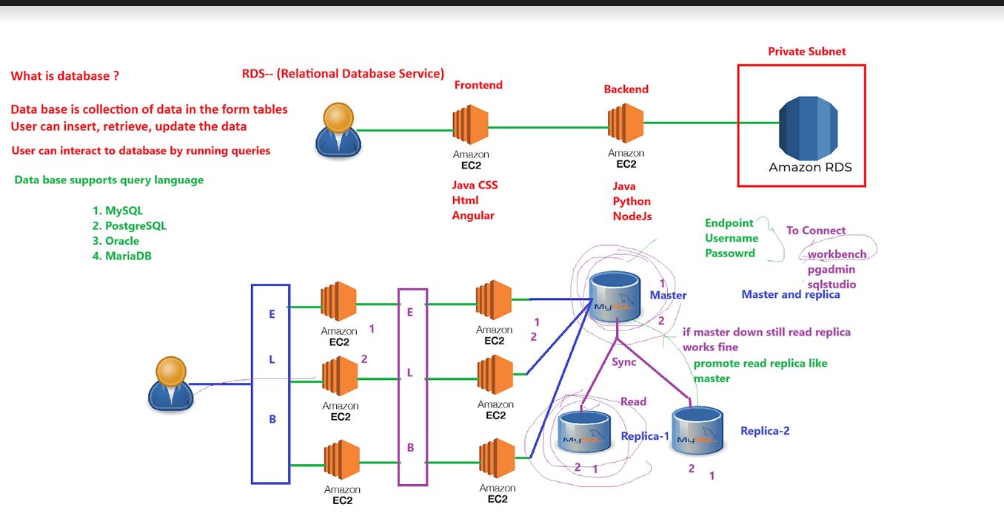

Screenshots for creating an Amazon RDS Instance

Create MySQL Database on AWS (RDS)

At the top of the AWS console, you’ll see a Search bar. Type "RDS" into the search field.
Click on RDS from the dropdown list that appears
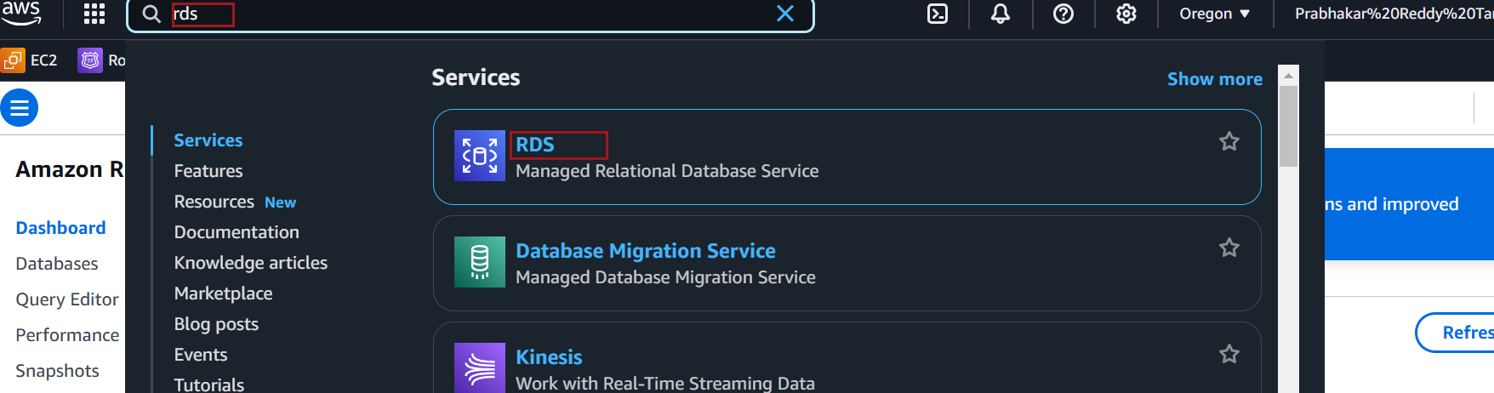

On the left-side pane, under the RDS Dashboard, you’ll see several options.
Click on Databases, then Click on "Create Database".
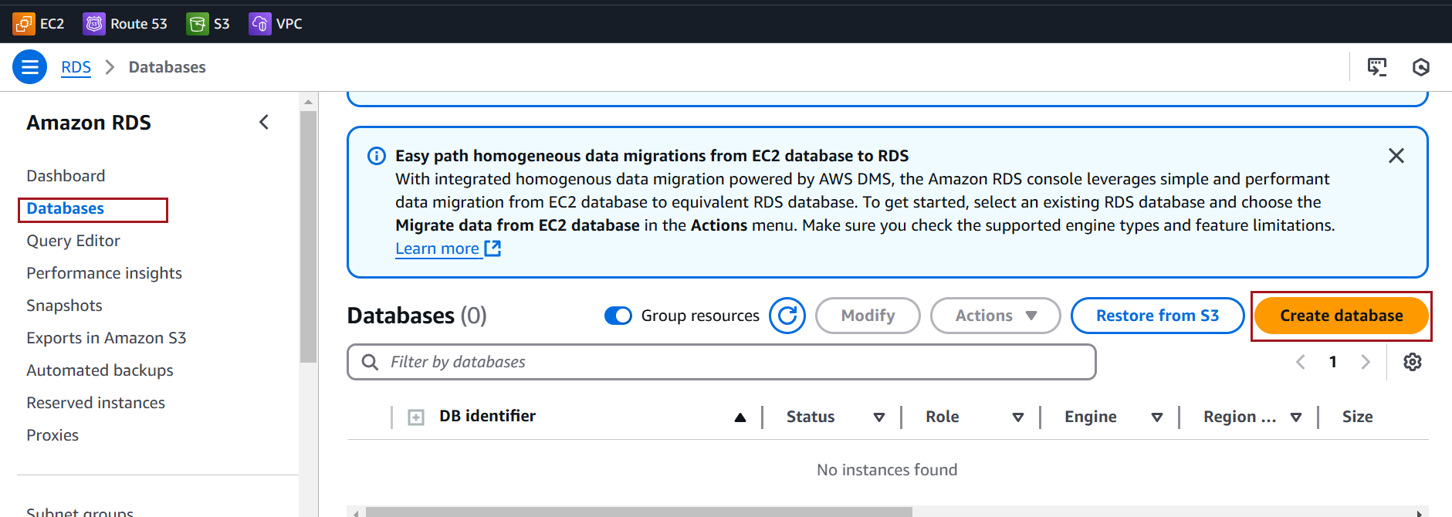

Choose Standard Create for detailed configurations

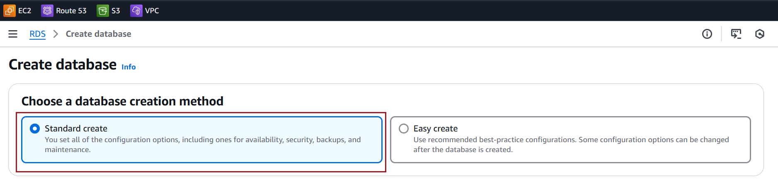

Engine type: Select MySQL.

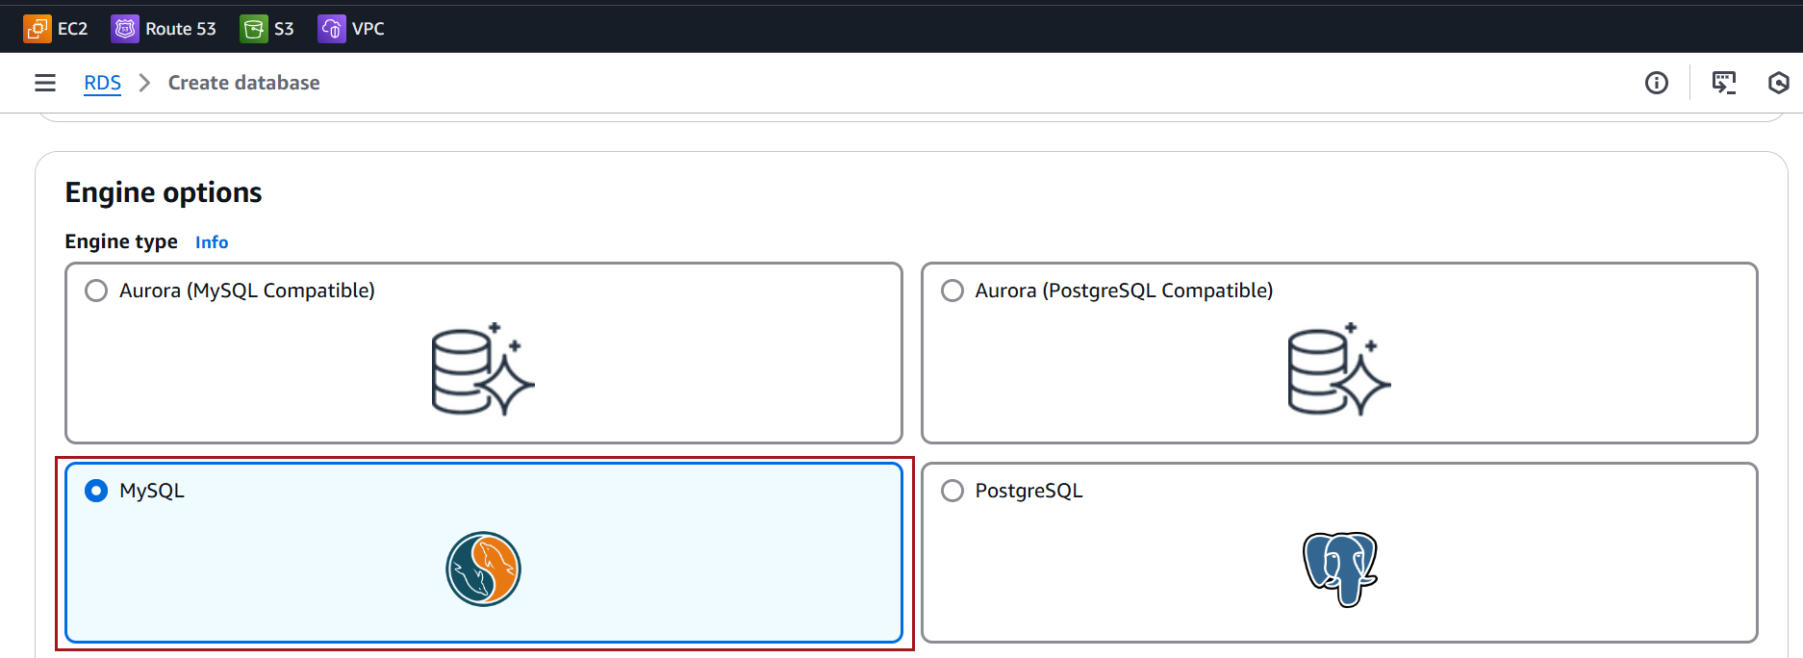

Version: Choose the MySQL version you prefer
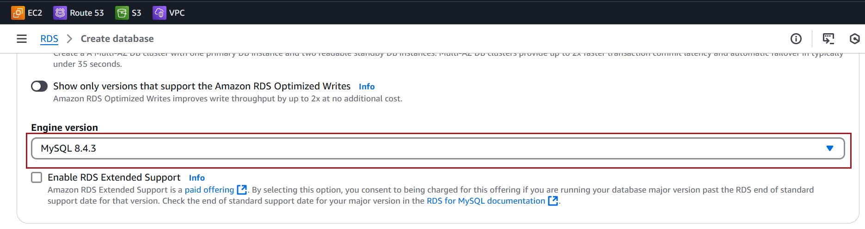

Choose a Free tier template for learning or experimenting with RDS at no cost
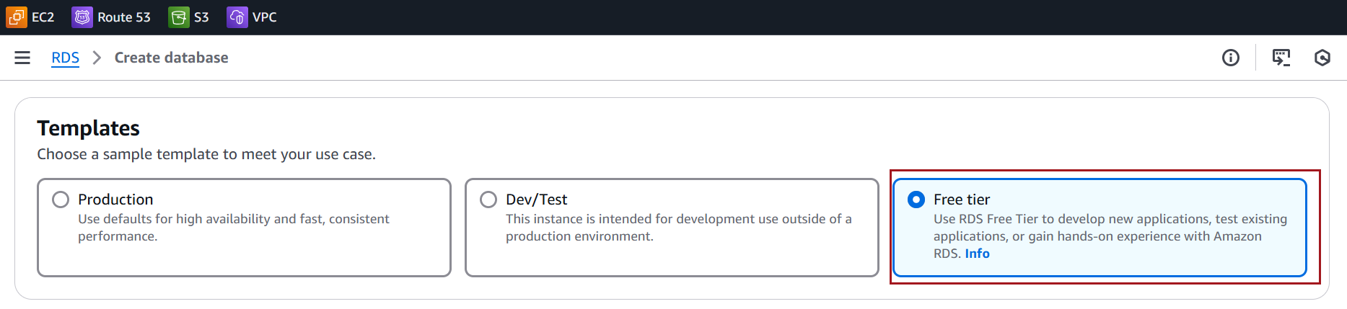

DB instance identifier: Enter a unique name for your database (e.g., my-sqlserver-db).
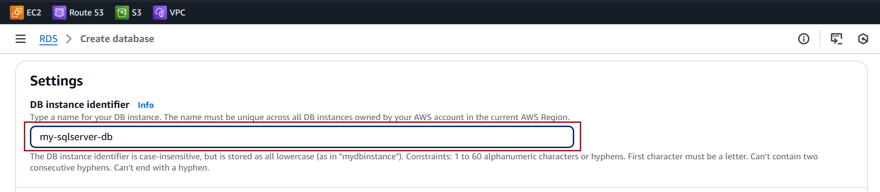

Master username: Set the admin username (e.g., admin).
Master password: Create and confirm a strong password.
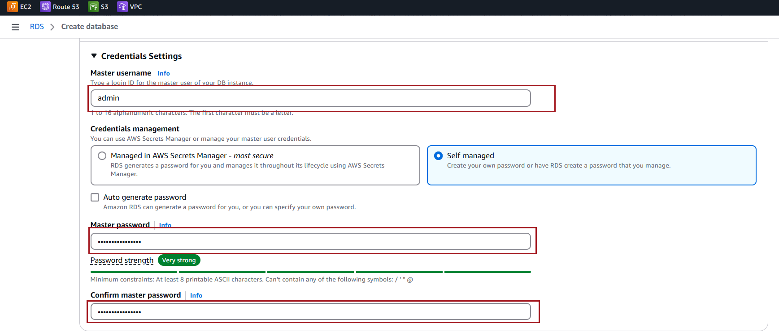

DB instance class: Choose the instance type based on workload needs:
- For testing: db.t3.micro (free tier eligible).
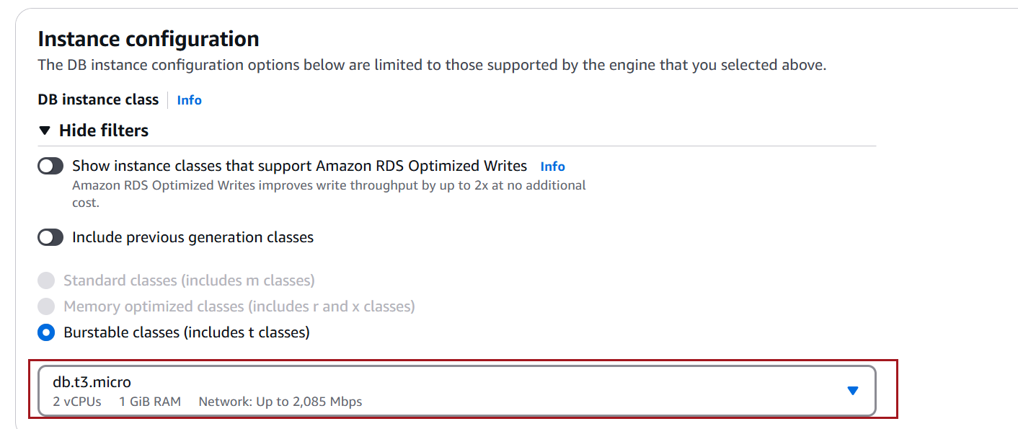
Allocated storage: Set the storage size (minimum 20 GiB).
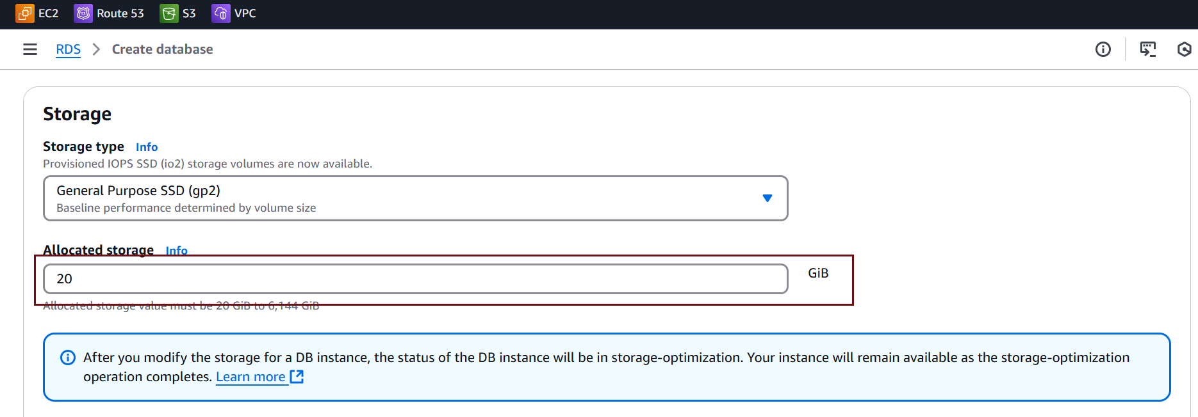
Choose Don’t connect to an EC2 compute resource option under Compute resource
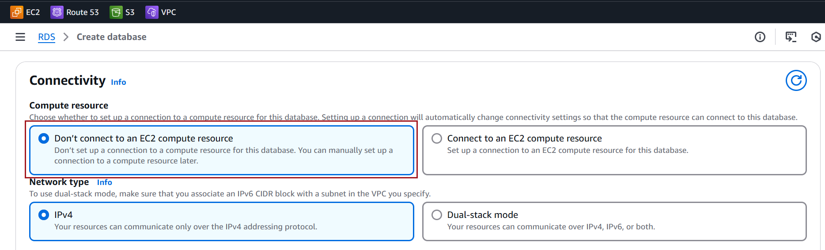

Virtual Private Cloud (VPC): Select an existing VPC or create a new one.
DB Subnet group: Choose a subnet group within the selected VPC.
Select Yes for Public access
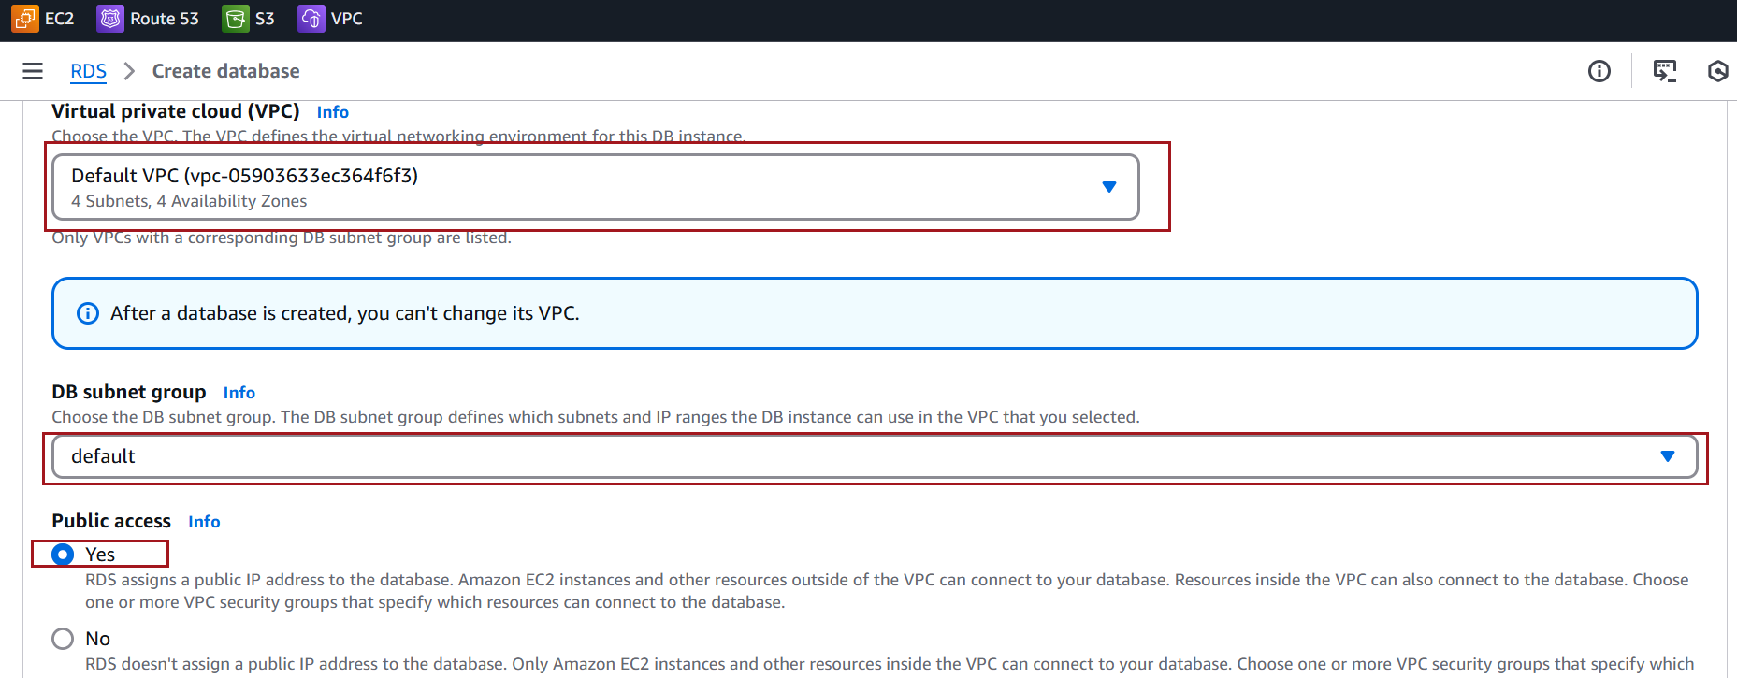

VPC security group:
- Ensure inbound traffic on port 3306 (default MySQL port) is allowed
- choose Availability Zone if required.
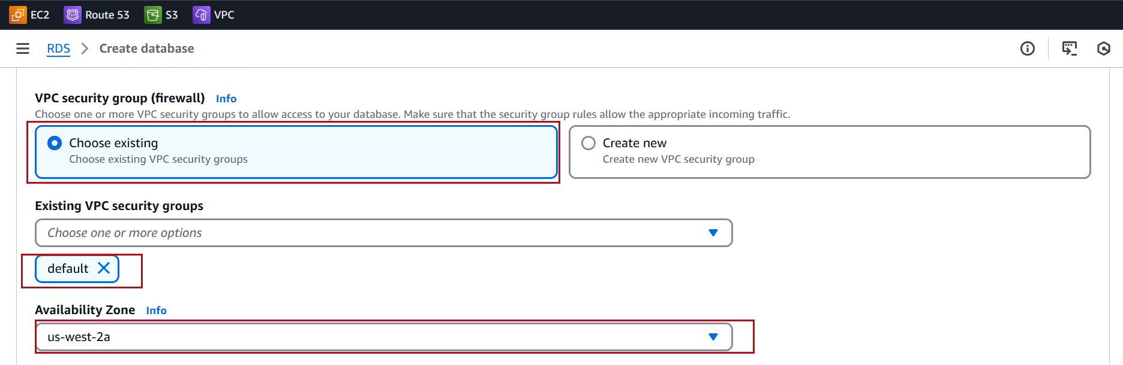

Click Create database
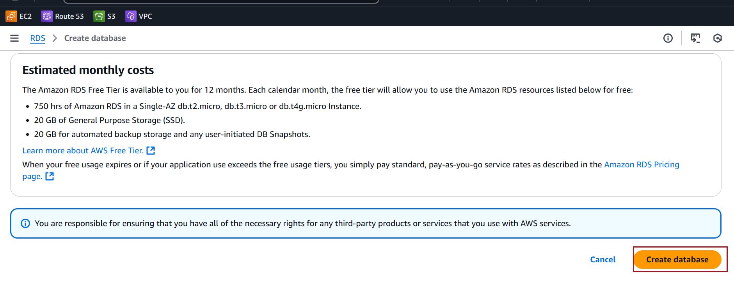

It may take a few minutes for the database status to change to Available
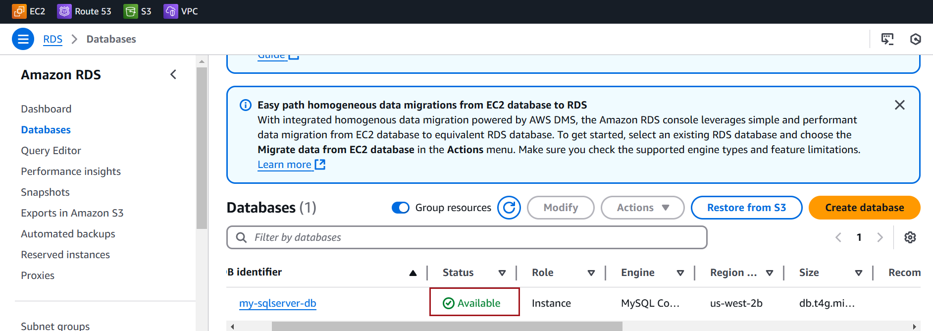

Install MySQL Workbench
Go to the MySQL Workbench Downloads.
Click on Download
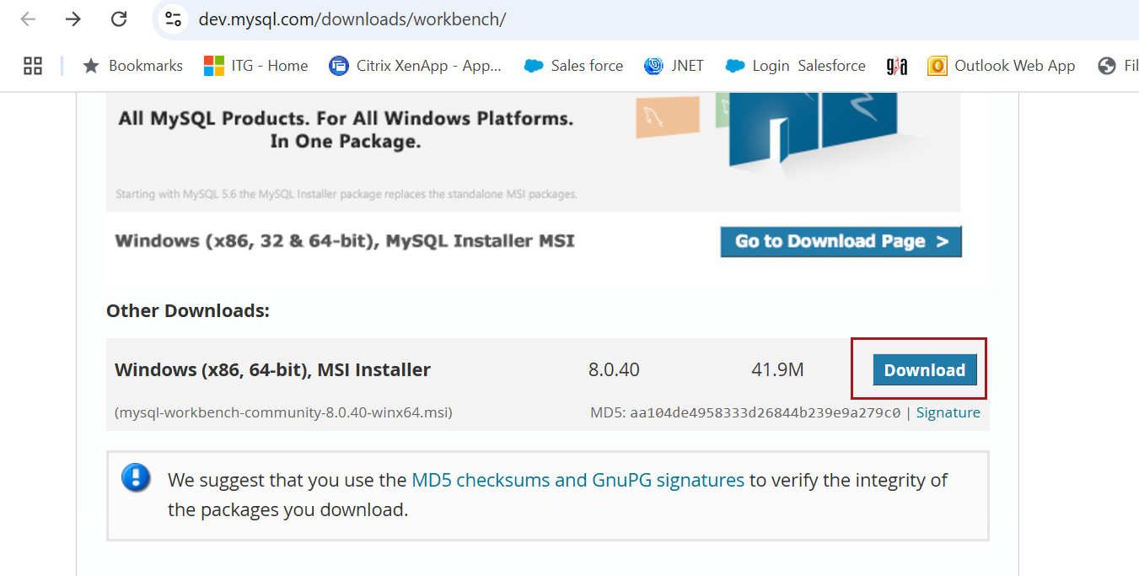
Click on No tanks, just start my download
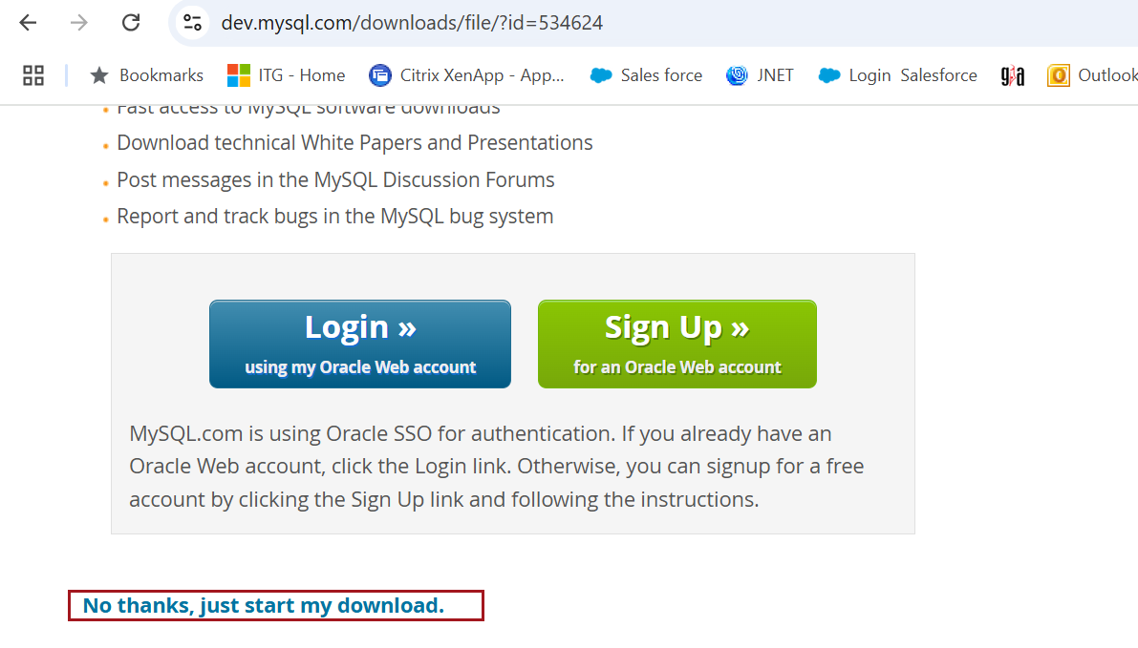

Locate the downloaded .msi file. Double-click the installer to run it
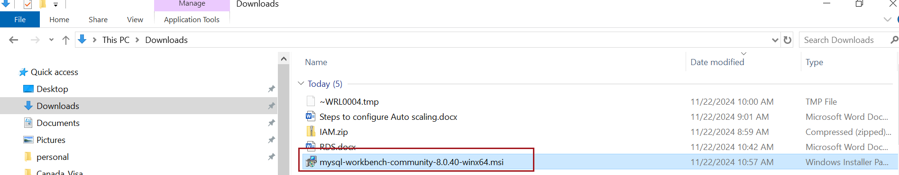

Follow the prompts, accepting the default settings.
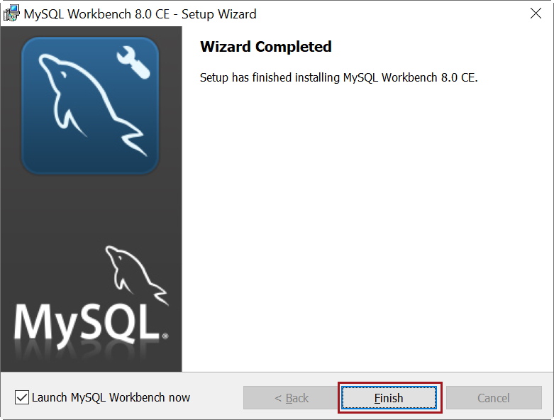

Open Workbench from the Start Menu or desktop shortcut.
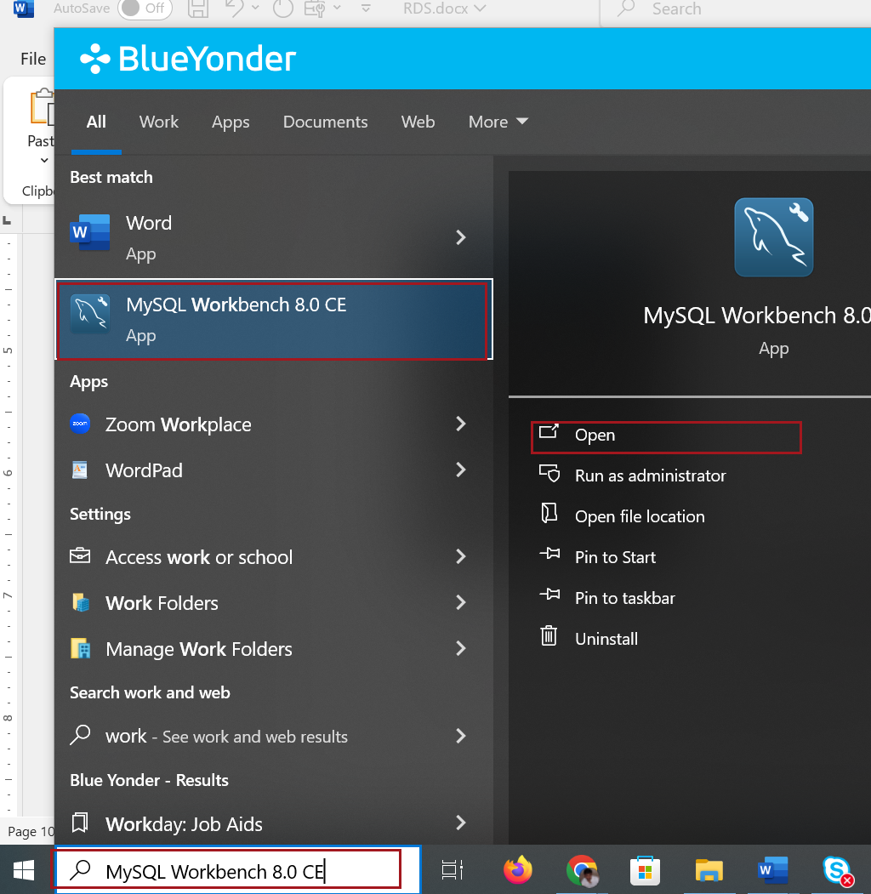

Connect MySQL Workbench to Your AWS Database
Select Database tab and click on Manage Connections
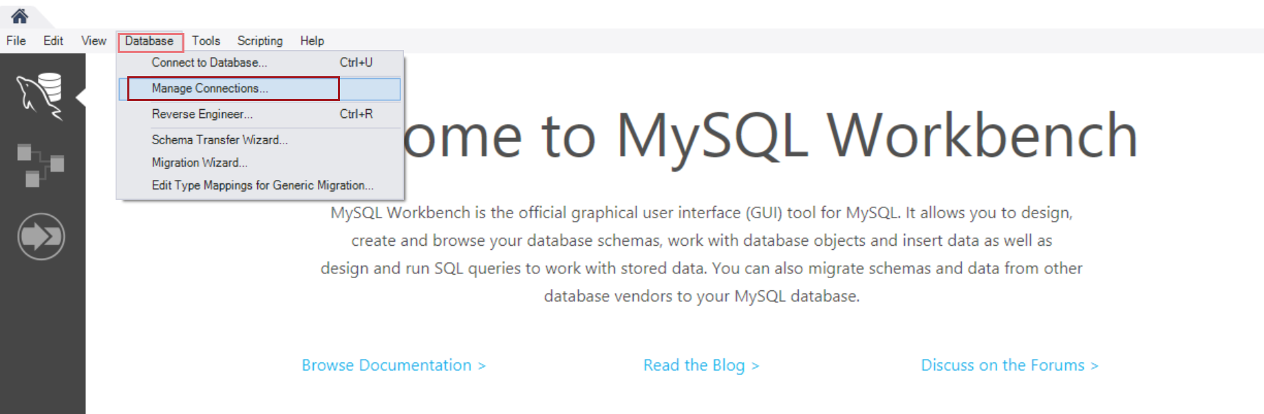

Copy the Endpoint to use in the connection creation

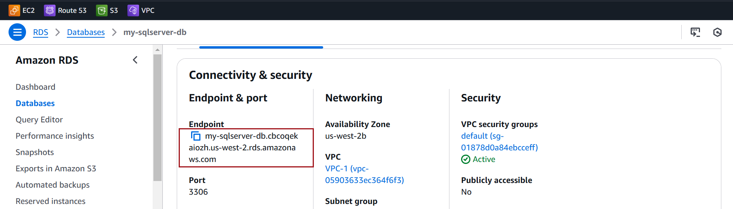

Connection Name: Give it a name (e.g., AWS MySQL).
Hostname: Enter your RDS endpoint.
Port: Default is 3306.
Username: The master username you created (e.g., admin).
Password: Click Store in Vault and enter the master password
Click Test Connection.

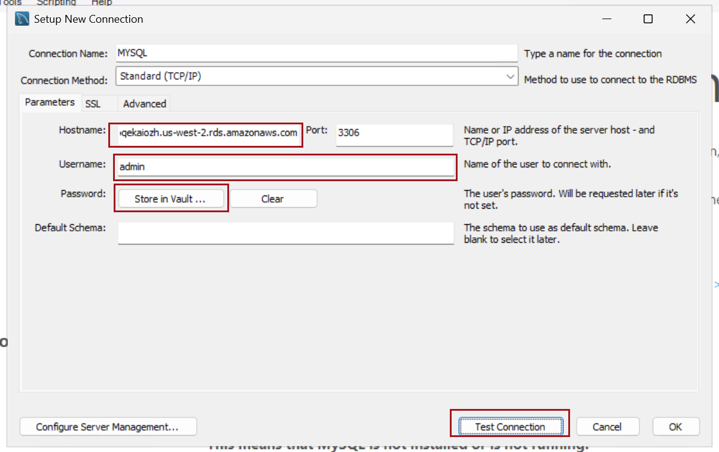

If successful, you'll see a message: Connection parameters are correct.

Click OK to save the connection. 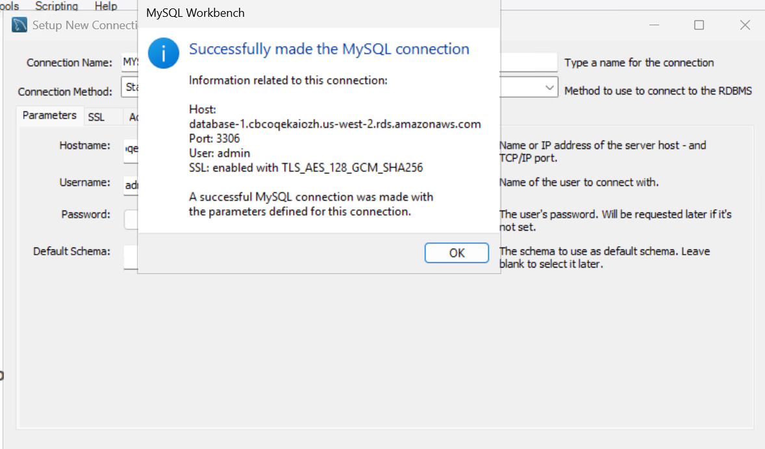

Double-click your saved connection in MySQL Workbench to connect to the MySQL RDS instance.
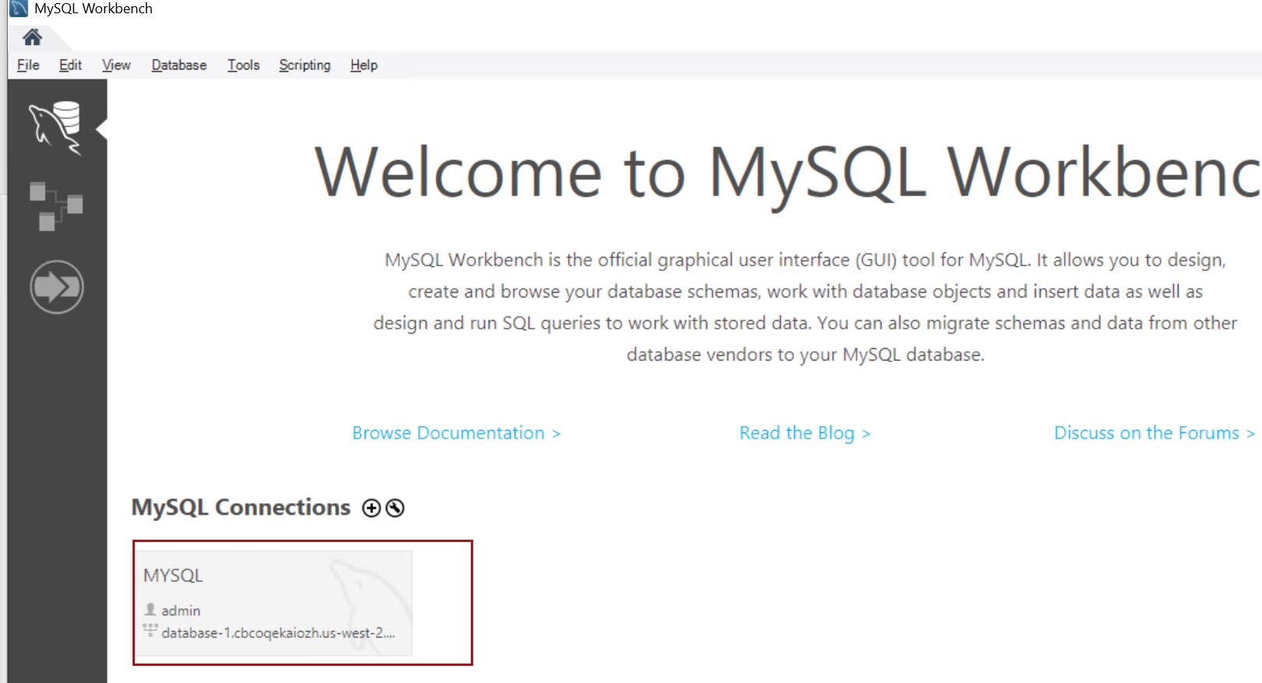

Create a New Database in MySQL Workbench
Type the following SQL command to create a new database:
CREATE DATABASE mytestdb;
Click the Execute button (lightning bolt icon).
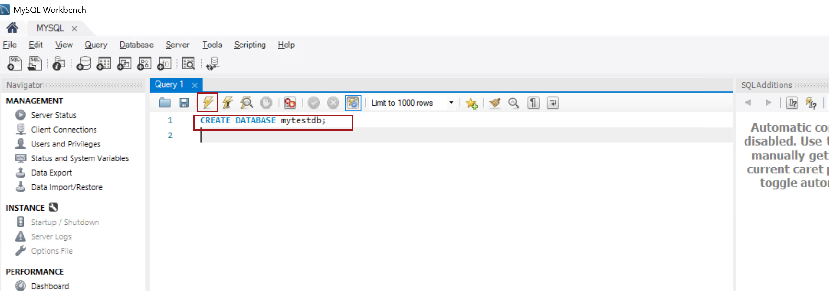

Check if the database was created, type
SHOW DATABASES;
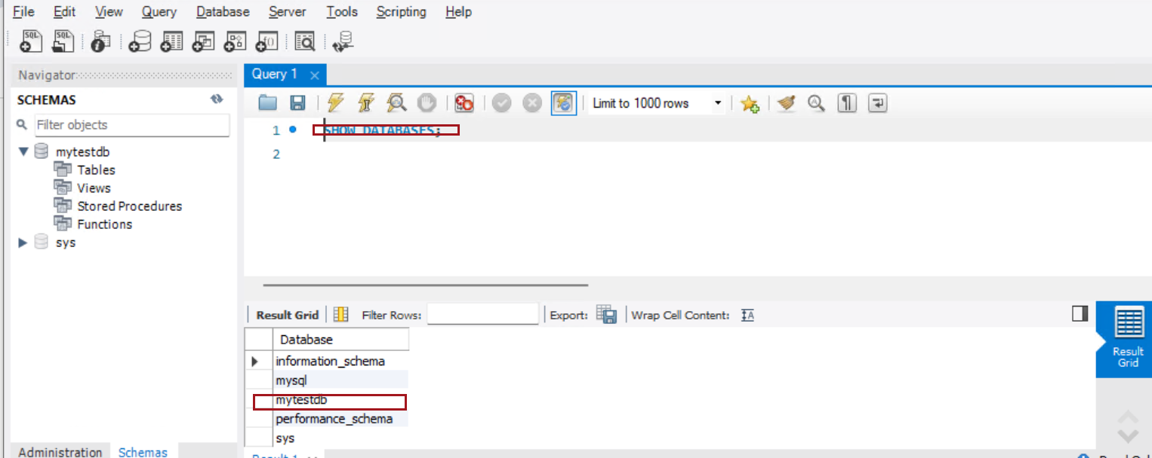

Manage Your Database
Now that you have created your database, you can perform various operations such as:
CREATE TABLE mytestdb.users (
id INT AUTO_INCREMENT PRIMARY KEY,
name VARCHAR(100));
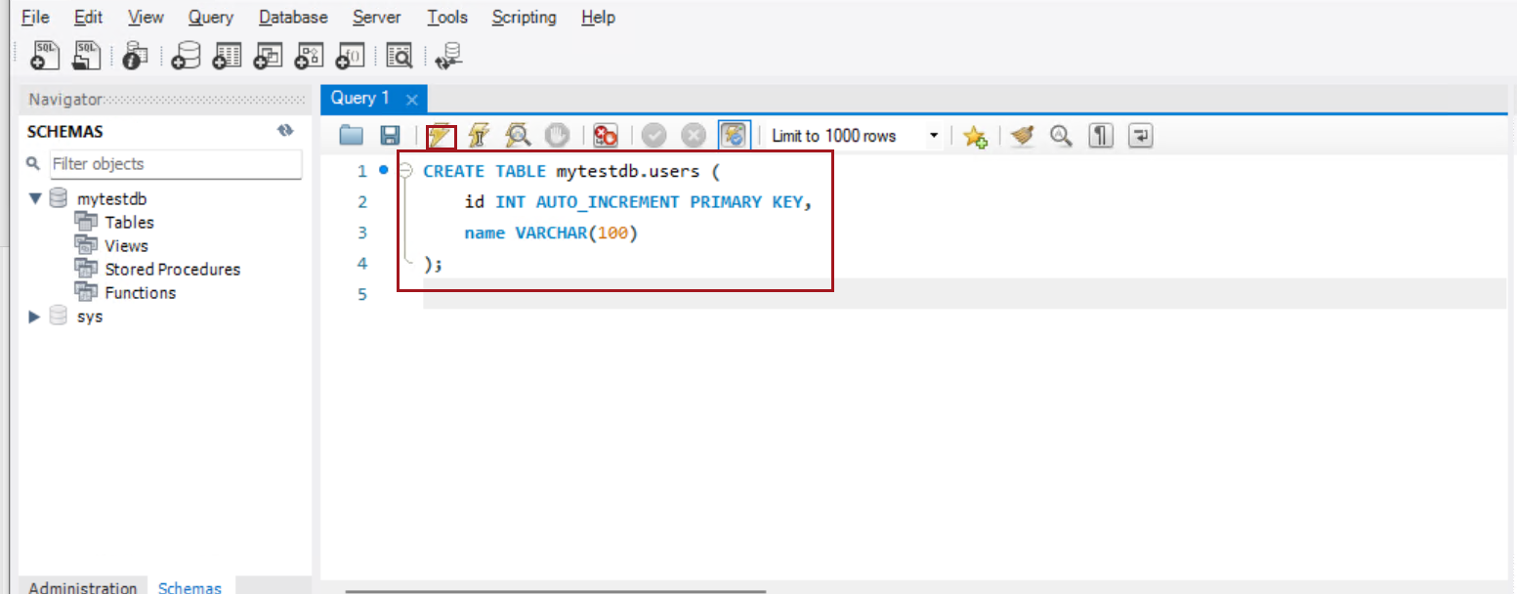

Insert data
INSERT INTO mytestdb.users (name) VALUES ('Prabhakar');
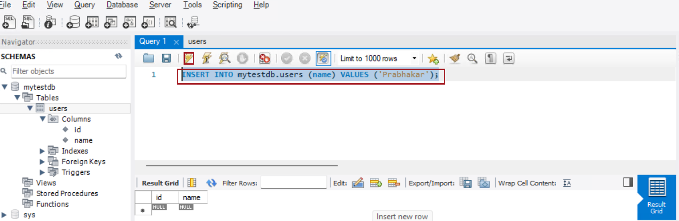

Check the data
select * From mytestdb.users;
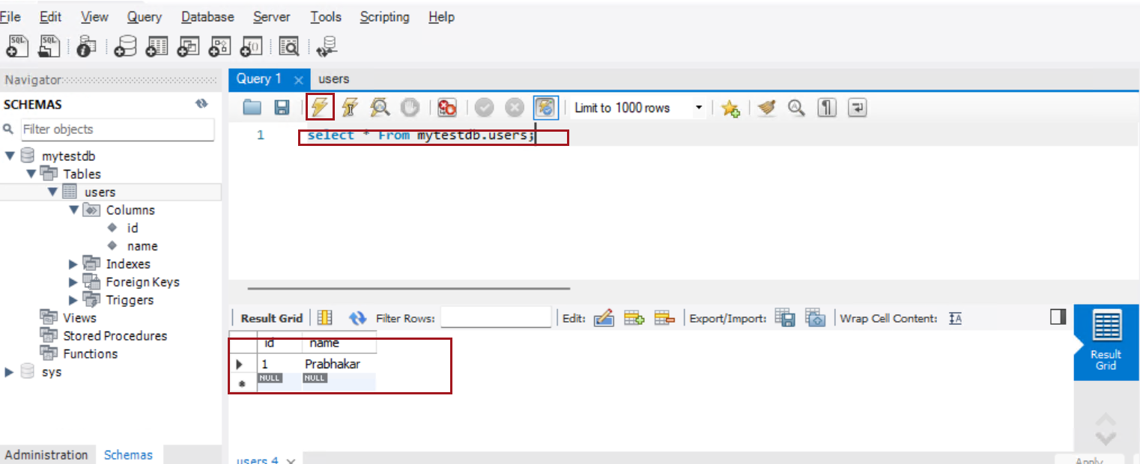

Screenshot for Read Replica

Create a Read Replica
In the RDS dashboard, find and click on your source database instance (the one you want to replicate).
Note – In Amazon RDS, the Create a Read Replica option is only available if the backup retention period is set to a non-zero value.
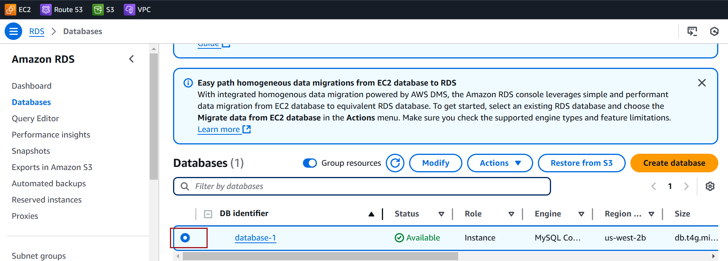

Click on the Actions dropdown menu for the selected instance.
Choose Create read replica.
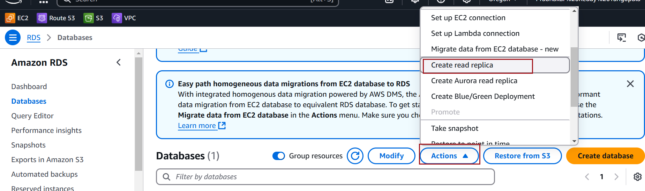

DB instance identifier: Choose a unique name for your read replica (e.g., mydb-replica).
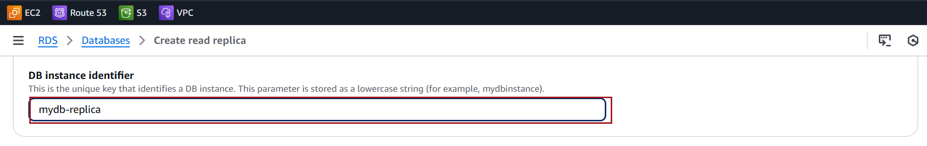
Leave other default value and click on create read replica
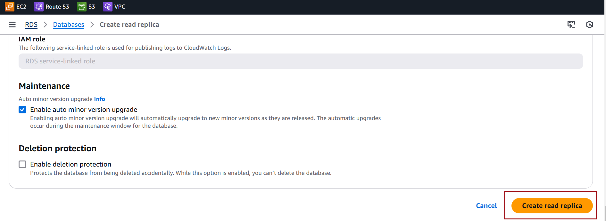

It will take a few minutes for the read replica to be created. You can monitor the process in the RDS Dashboard.
The status of the read replica will show as Creating initially. Once it’s available, the status will change to Available.

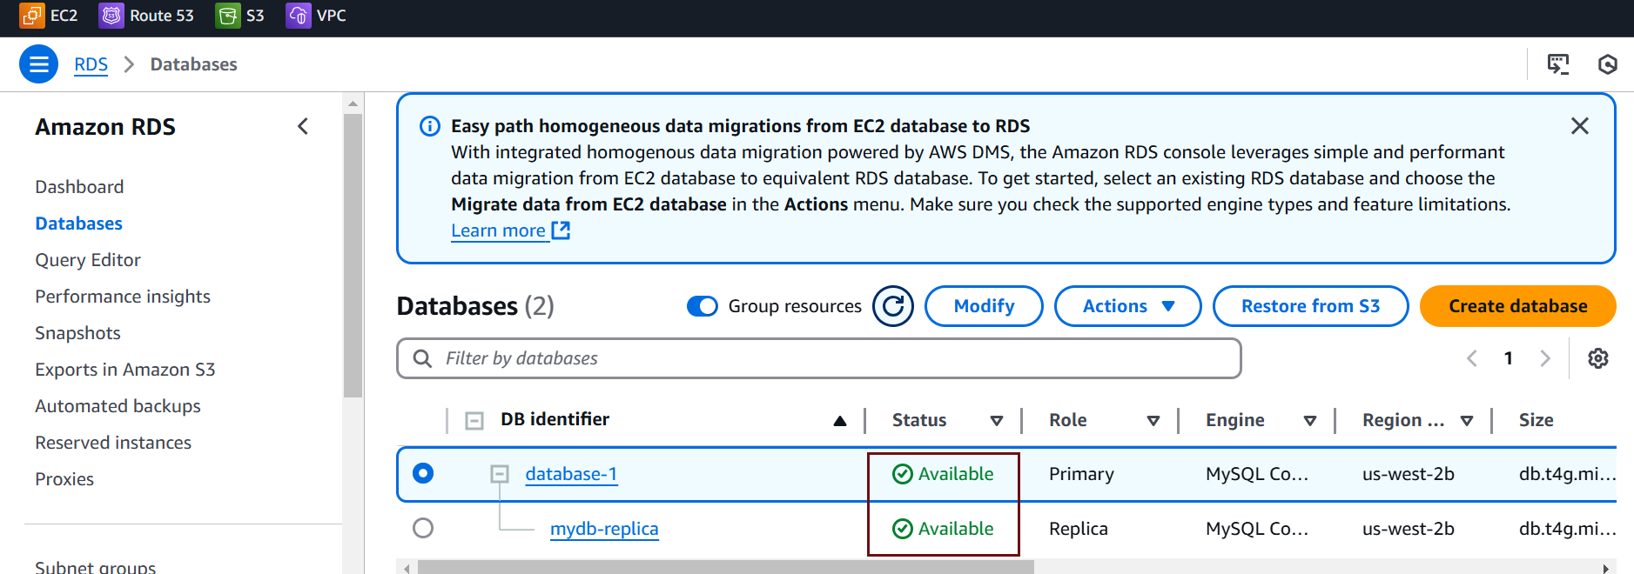

Access the Read Replica
Open MySQL Workbench and create a new connection
For the Hostname, use the endpoint of the read replica.
Use the username and password that you set for your MySQL instance.
Port: Default is 3306.
Click Test Connection and then OK to save the connection.
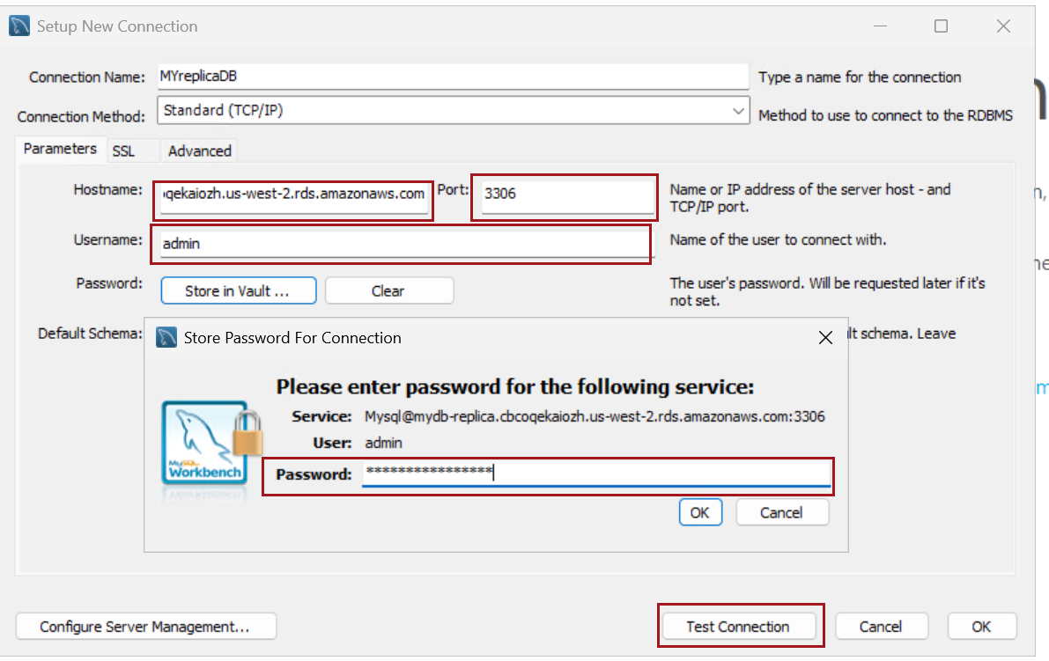
If successful, you'll see a message: Connection parameters are correct.

Click OK to save the connection.
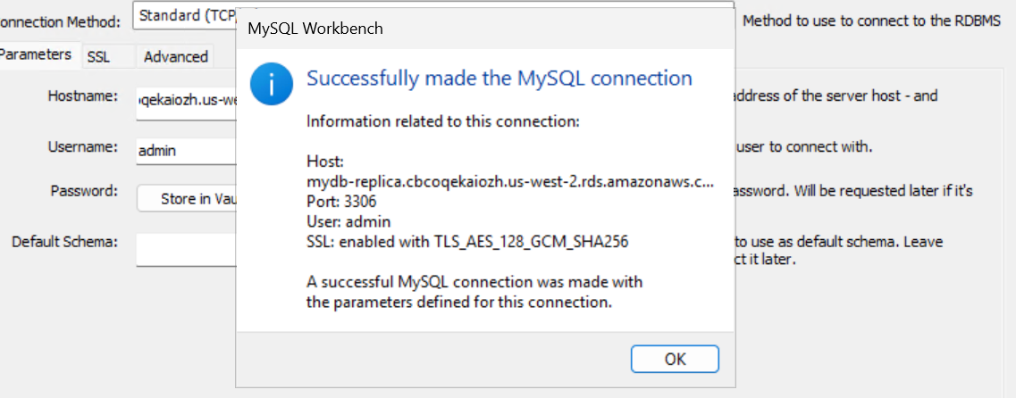

Check the data
select * From mytestdb.users;
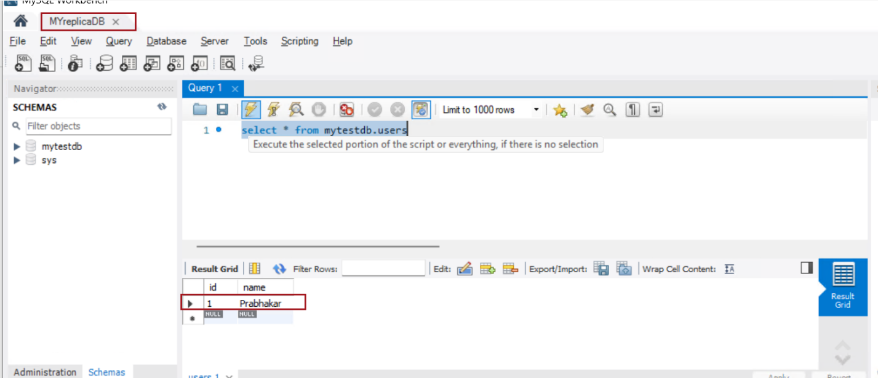

Test Replica action
To observe replication in action, add some data to the source database and monitor the read replica
Connect to the source database
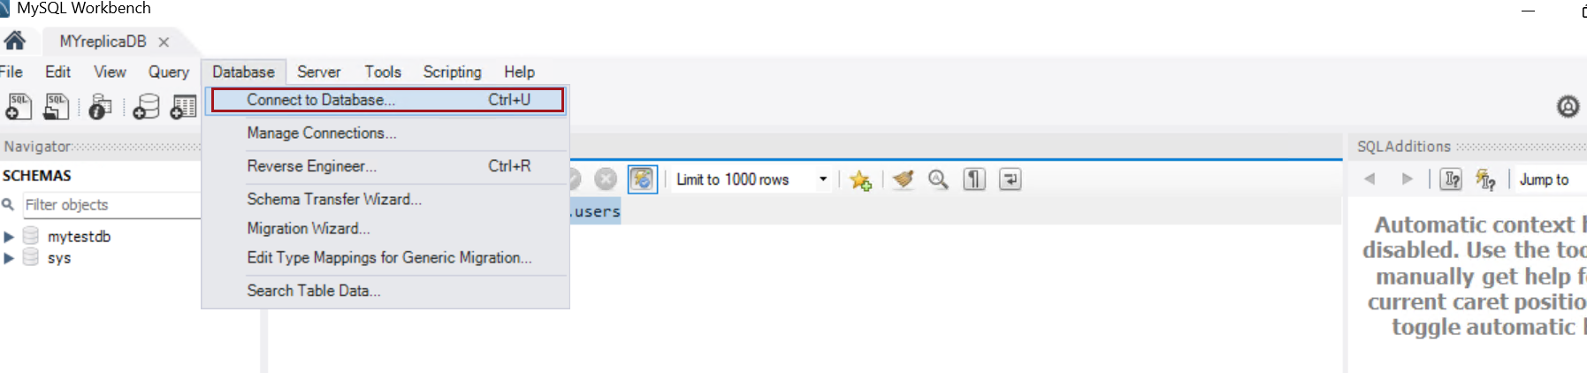

Select source database connection and click OK
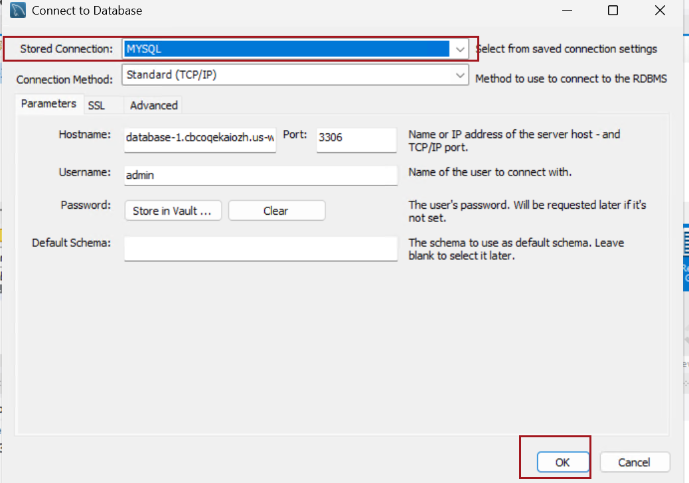

Use the SQL Query tab and run a simple INSERT query
INSERT INTO mytestdb.users (name) VALUES ('Veera');
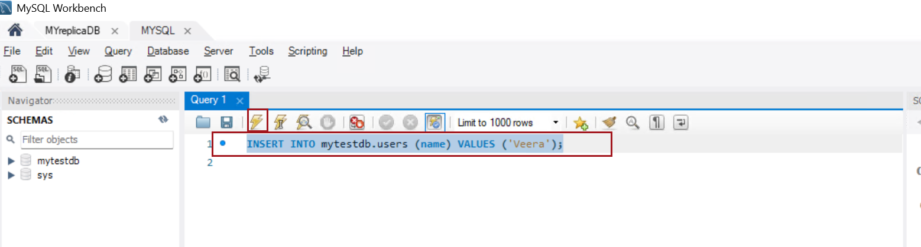

after inserting data, you can check that it was successfully added to the source database:
run a select query
select * From mytestdb.users;
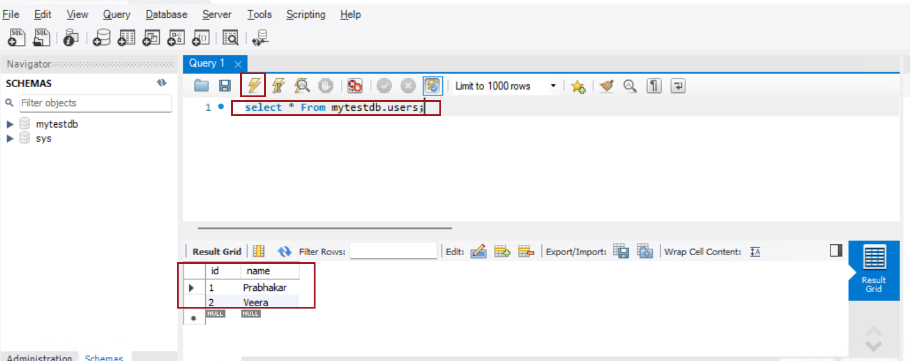
Check the Data in the Read Replica
After the data has been inserted into the source database, run the same query to check if the data is reflected in the replica:
Expected Result: You should see the same data
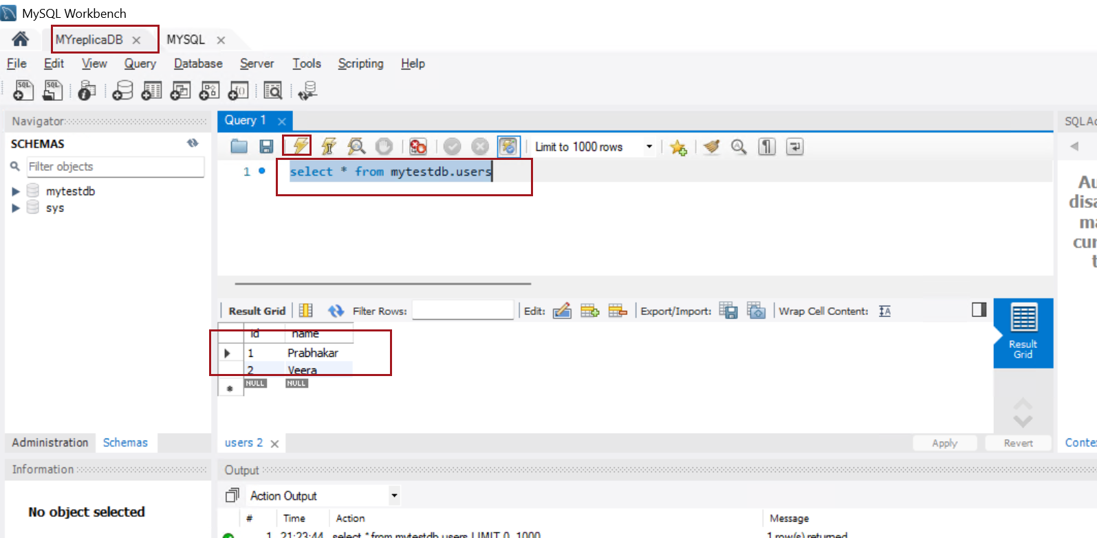

Snapshot

Screenshot for creating a Snapshot

In the left navigation pane, select Databases
Click on the database for which you want to create a snapshot
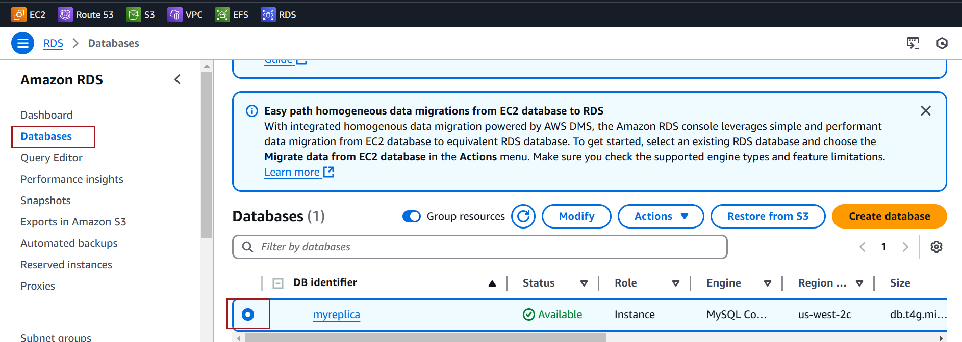

Click on the Actions dropdown menu. Select Take Snapshot
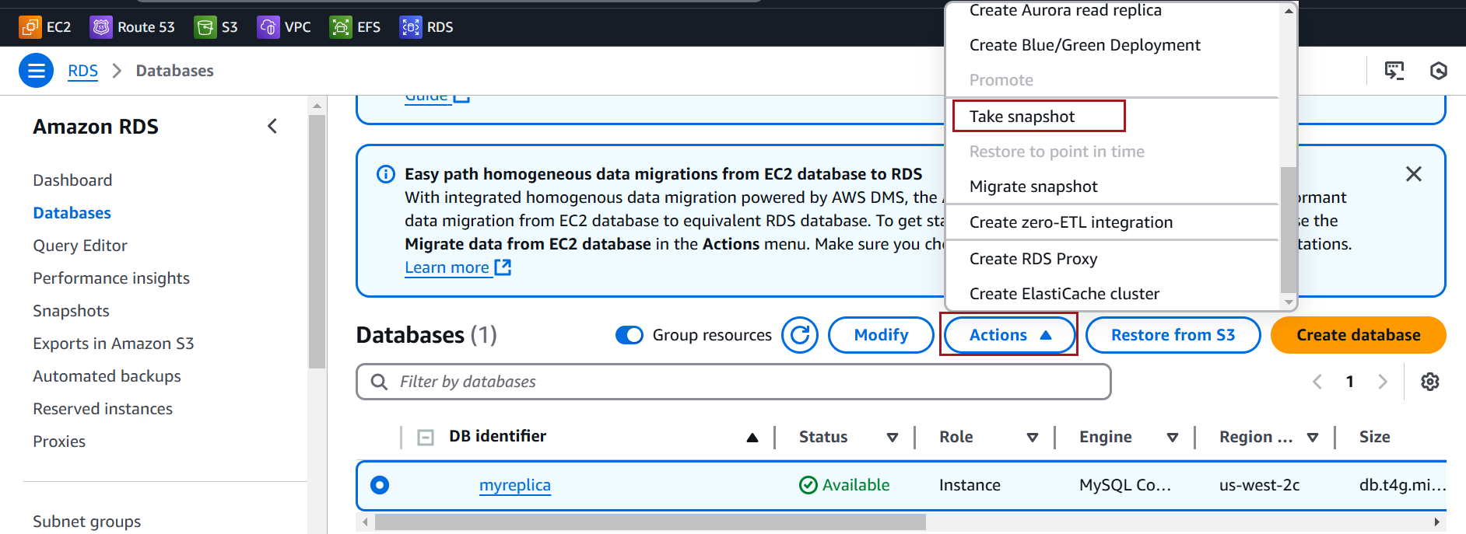

Enter a name for your snapshot.
click Take Snapshot
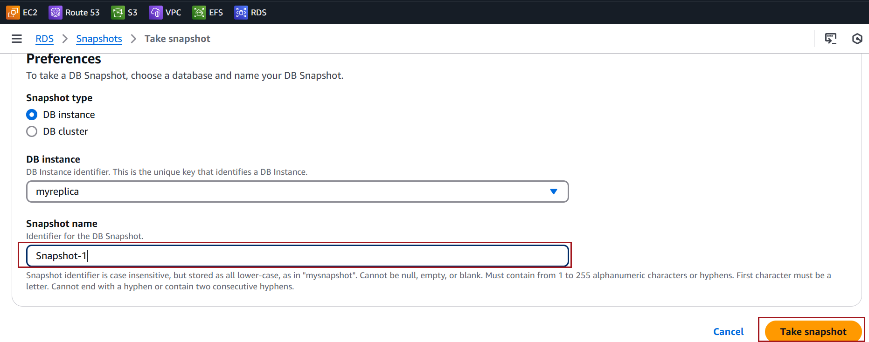
You will see the new snapshot listed with the status Creating
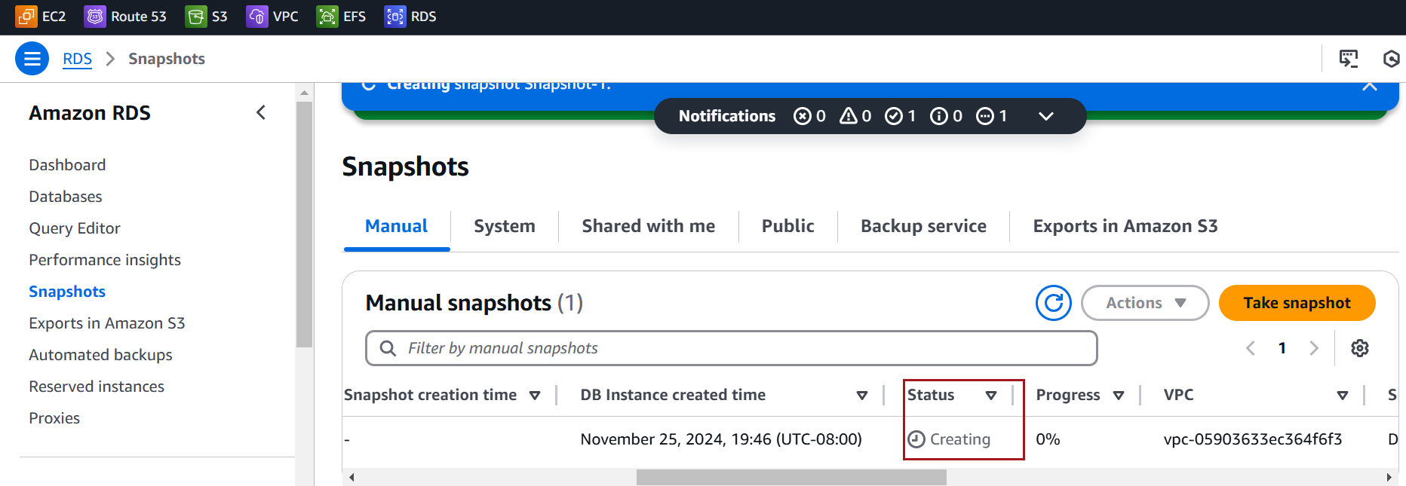

Wait until the snapshot status change to Available once complete
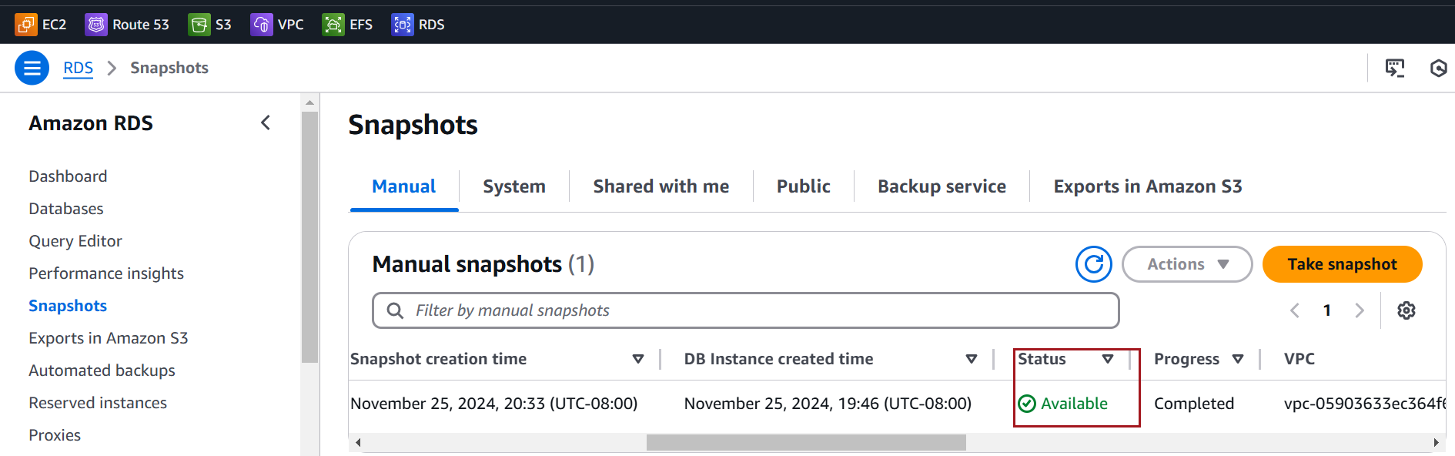

Screenshot for Restoring a Snapshot:
In the left navigation pane, click on Snapshots. Choose the snapshot you want to restore
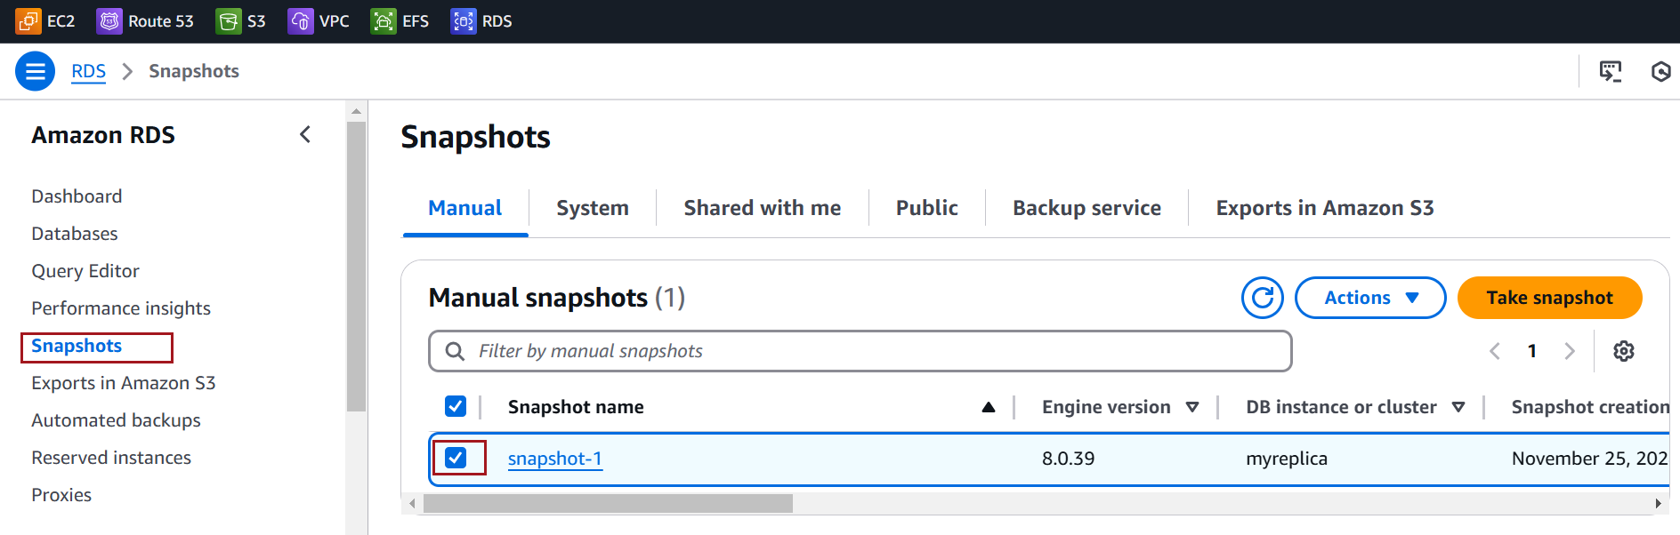
Click the Actions dropdown and select Restore Snapshot
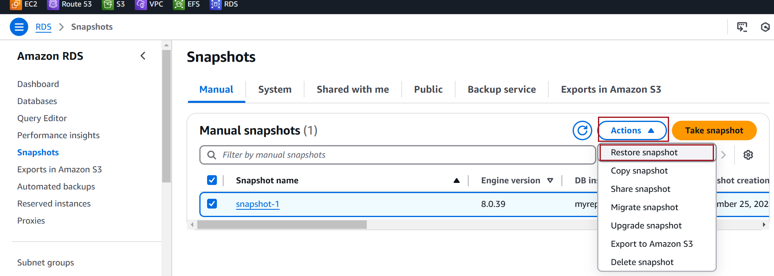

Enter a name for the new database instance
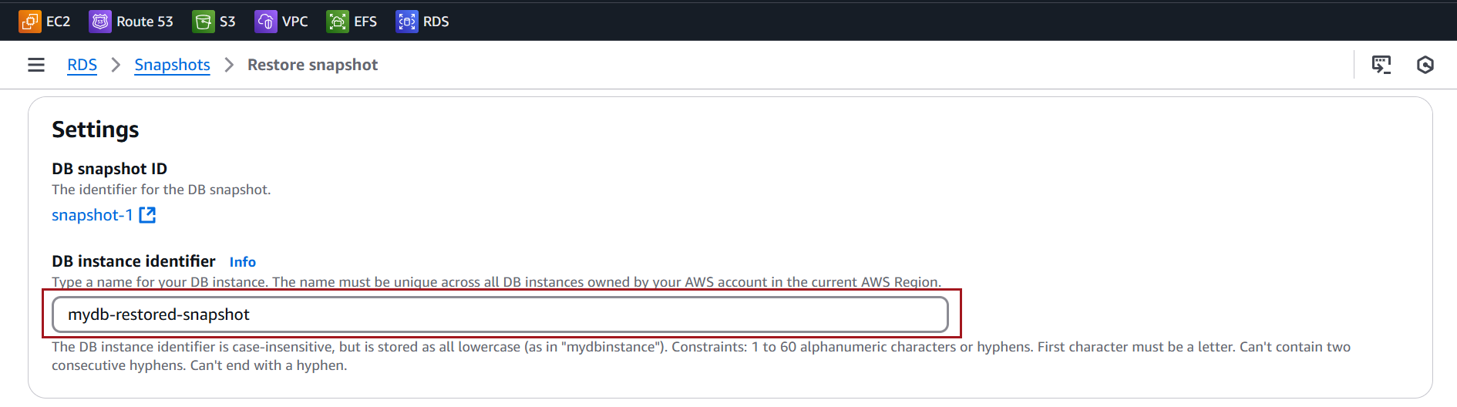

VPC and Security Groups: Ensure the new instance is in the correct network.
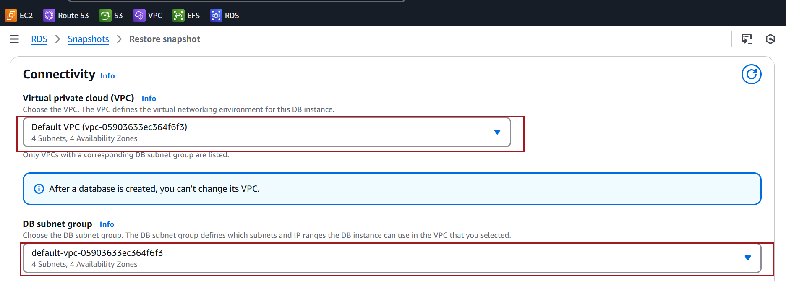

Leave all other settings as is and Click Restore DB Instance
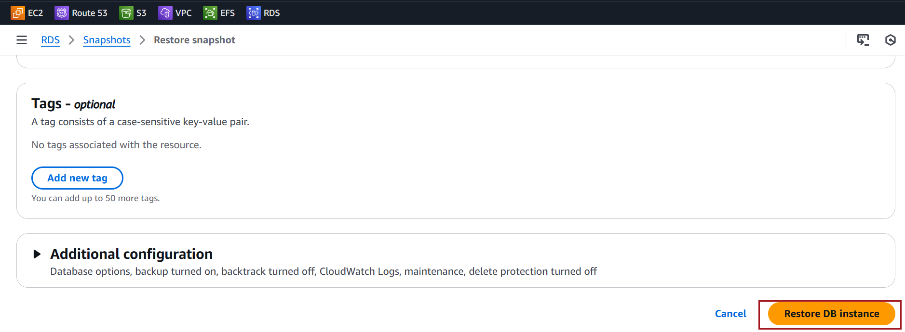
Your new database will appear under Databases with the status Creating
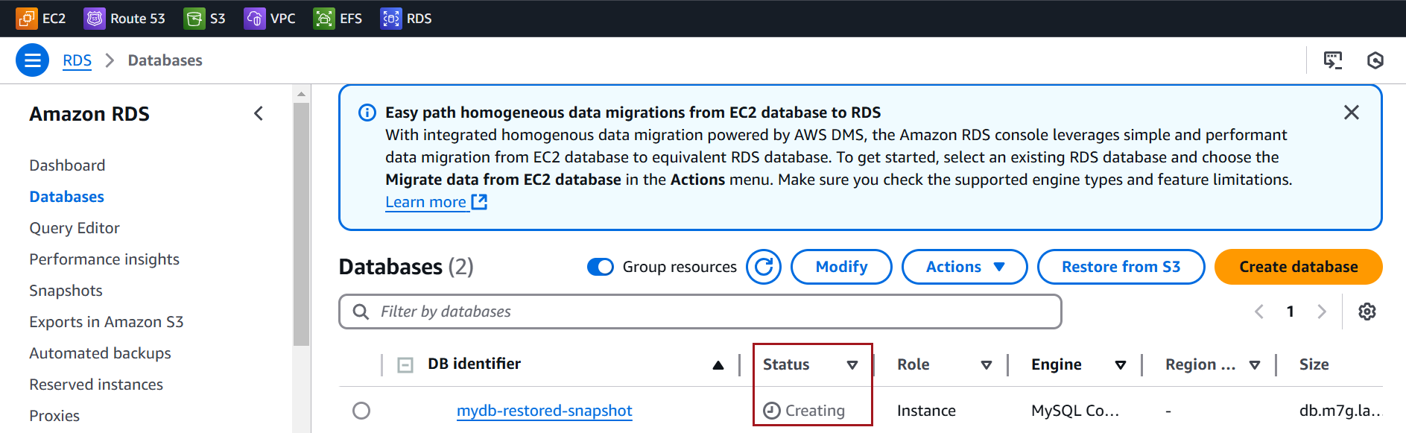

Wait for it to become Available.
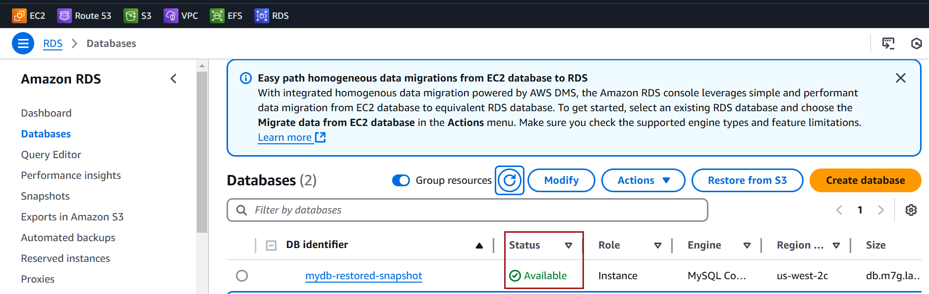

you can connect to the restored instance using the endpoint provided by AWS.
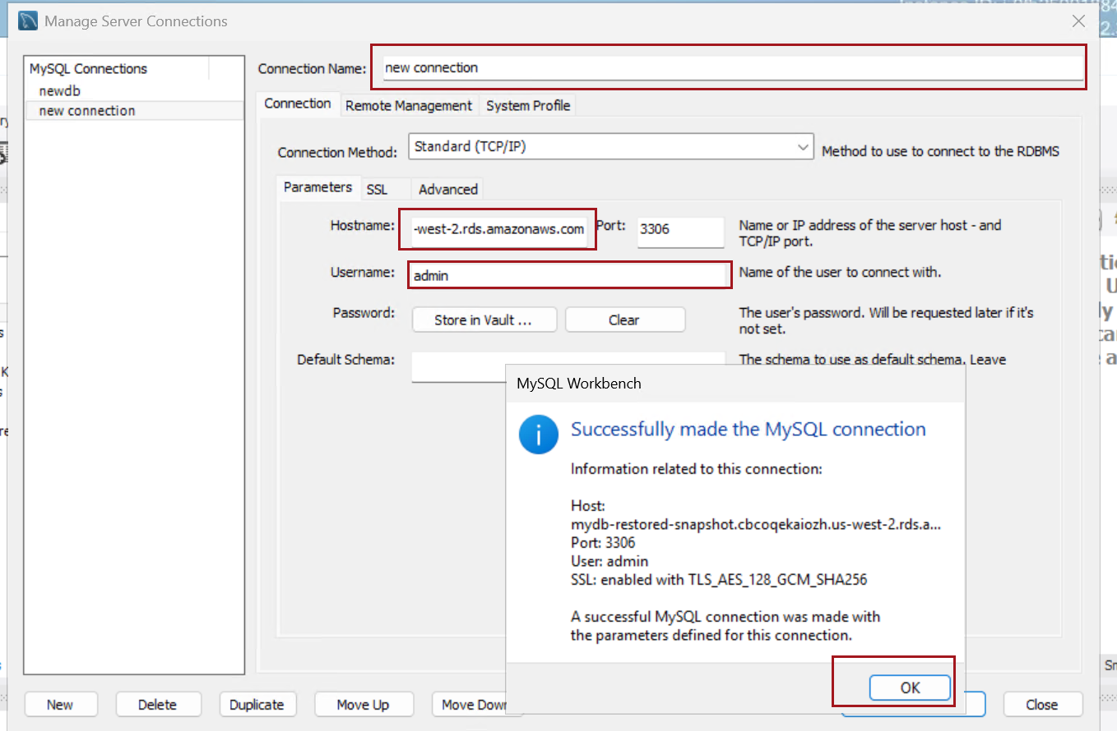

Screenshot of Copying a Snapshot
In the RDS dashboard, click on Snapshots in the left-hand menu under Databases
Find the snapshot you want to copy from the list. Click the checkbox next to the snapshot
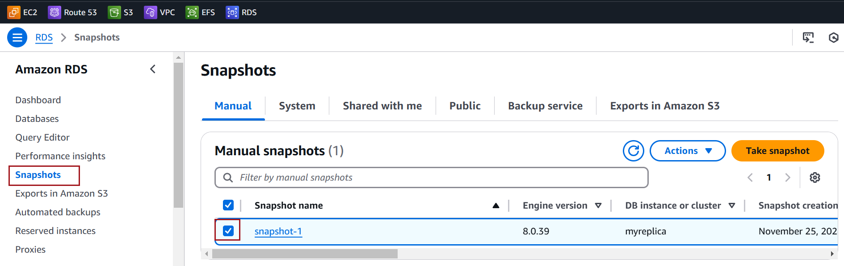
With the snapshot selected, click the Actions dropdown at the top.
Choose Copy Snapshot from the menu.
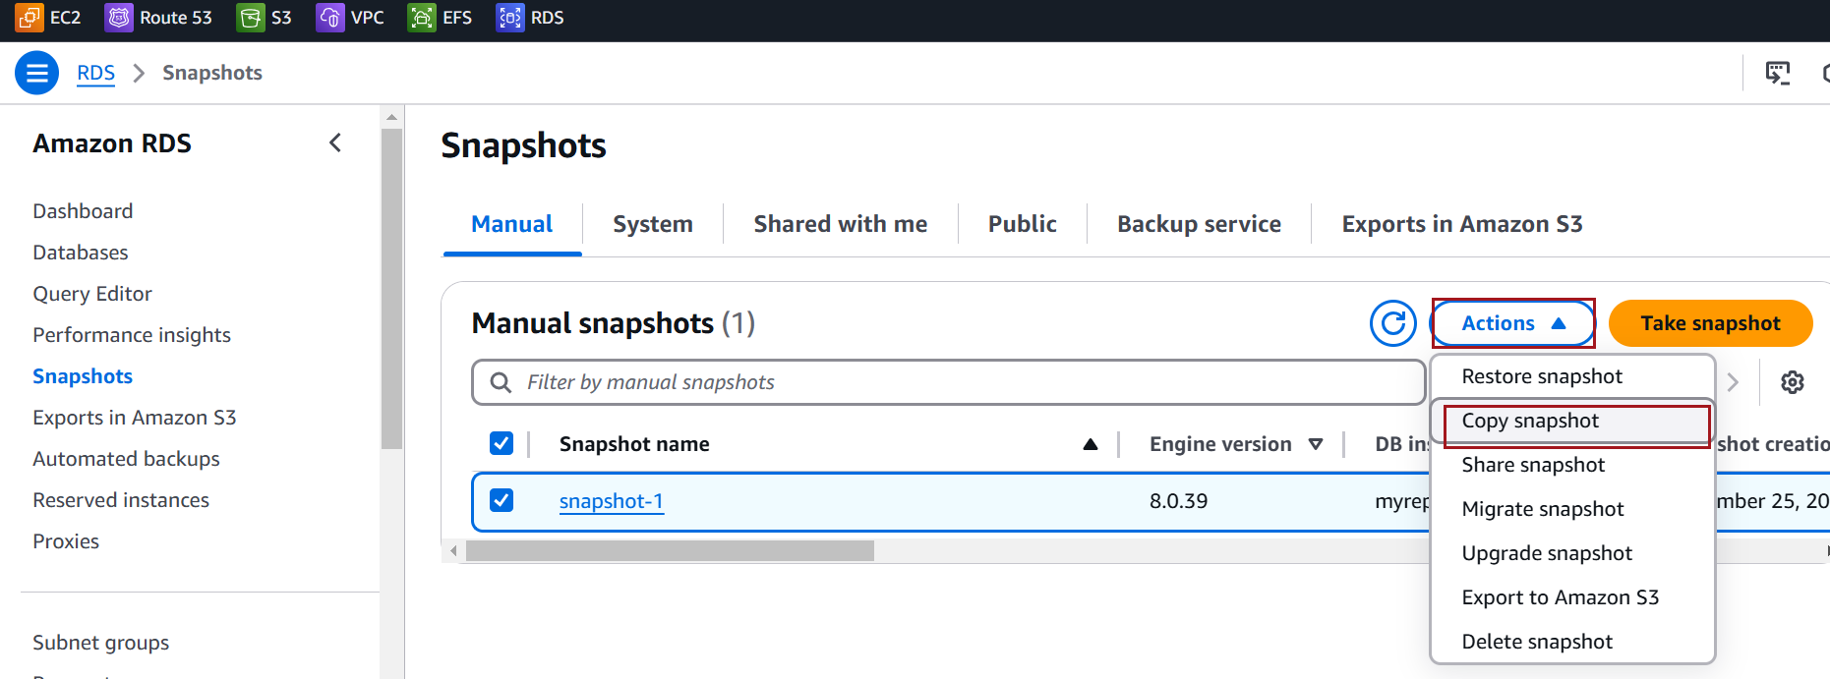

New DB Snapshot Identifier: Provide a new name (identifier) for the copied snapshot. Ensure it’s unique in the target region.
Destination Region: Select the target region where you want to copy the snapshot. If you’re copying it within the same region, leave this as it is.
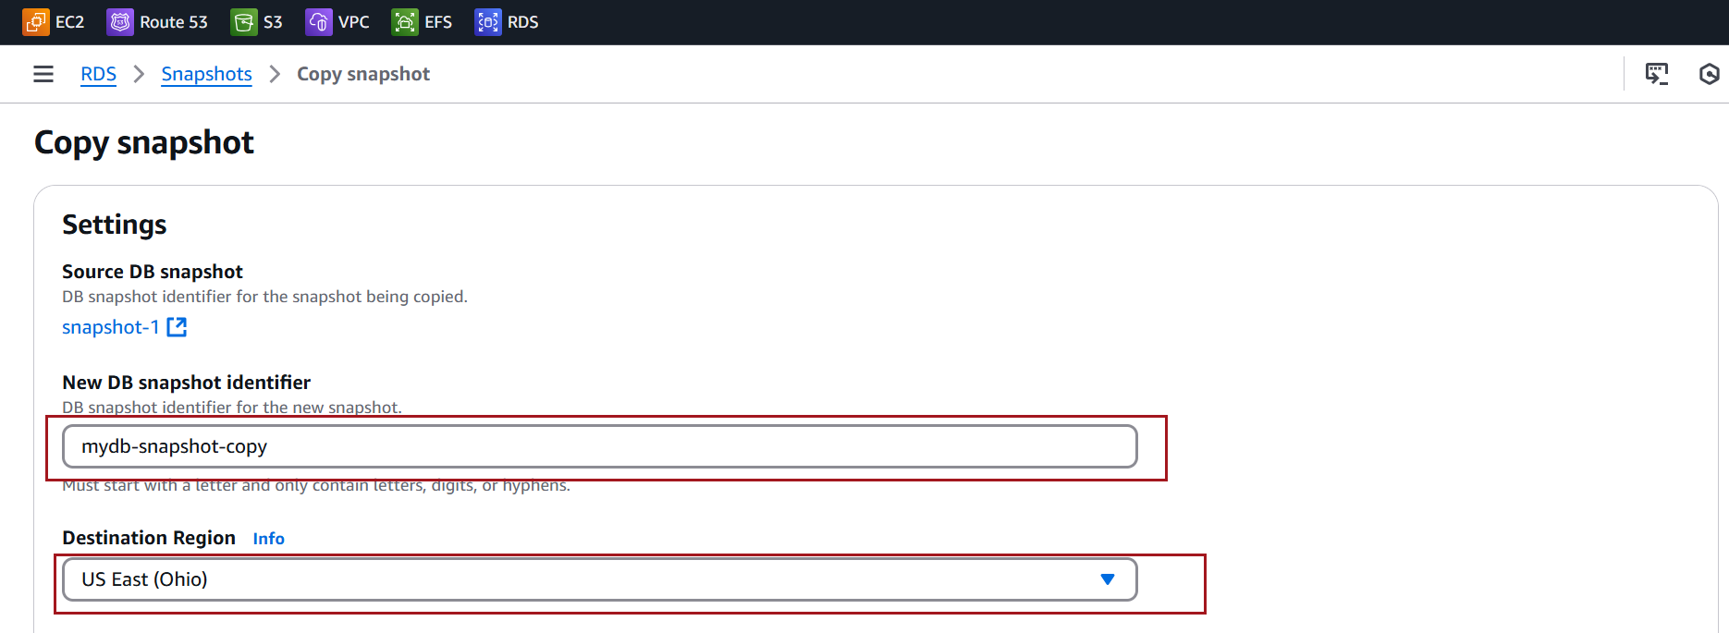

Click on Copy Snapshot to initiate the process
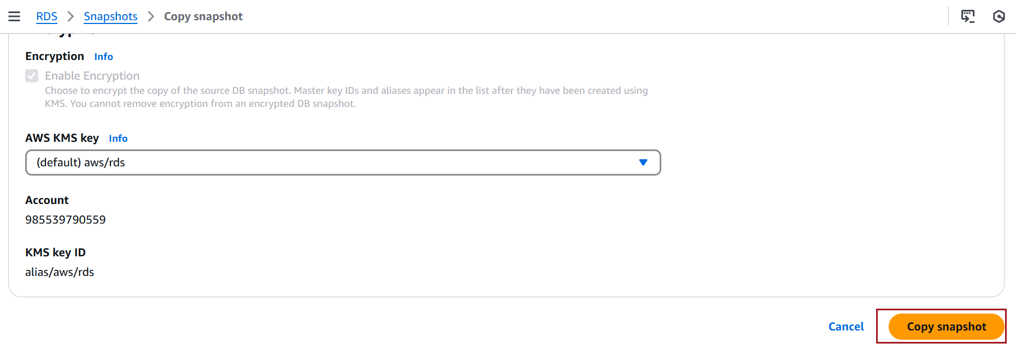

Go to Snapshots and monitor the status in the selected region. The status will show as Creating until the process completes, after which it will change to available
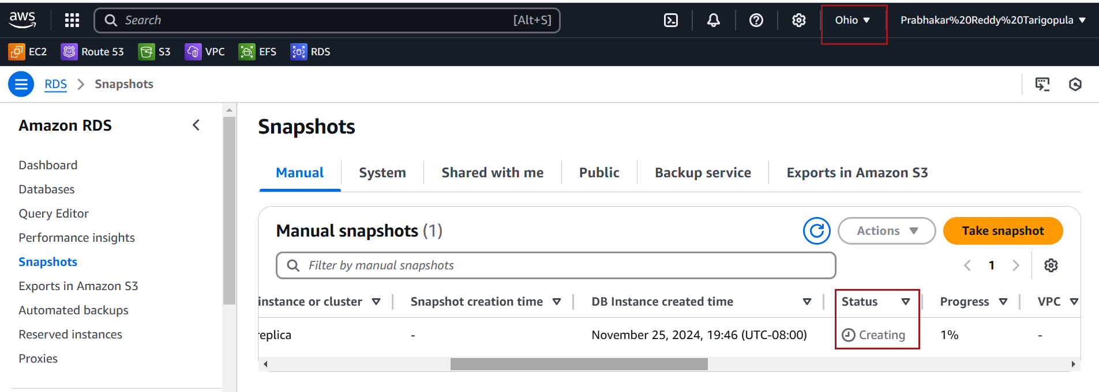

Once the copy is complete, the status will change to available, and the snapshot is ready to use
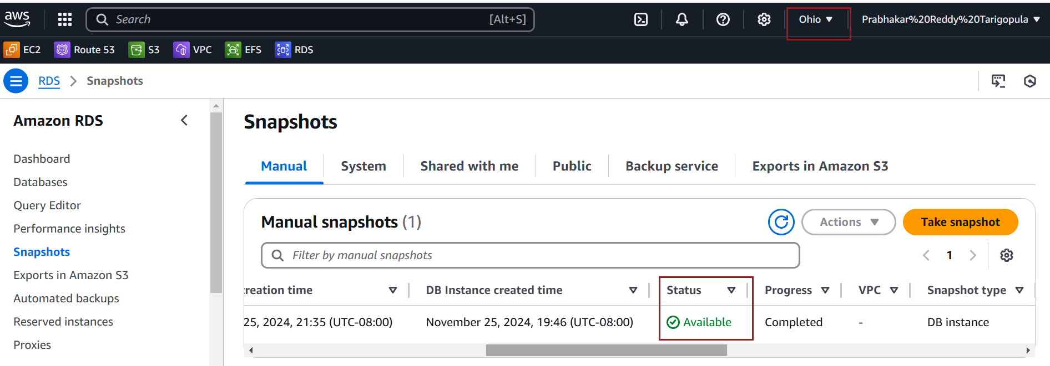

Screenshot of Sharing a Snapshot
From the list of available snapshots, select the snapshot you want to share by clicking the checkbox next to it.

With the snapshot selected, click on the Actions dropdown at the top of the page.
Select Share Snapshot from the dropdown.
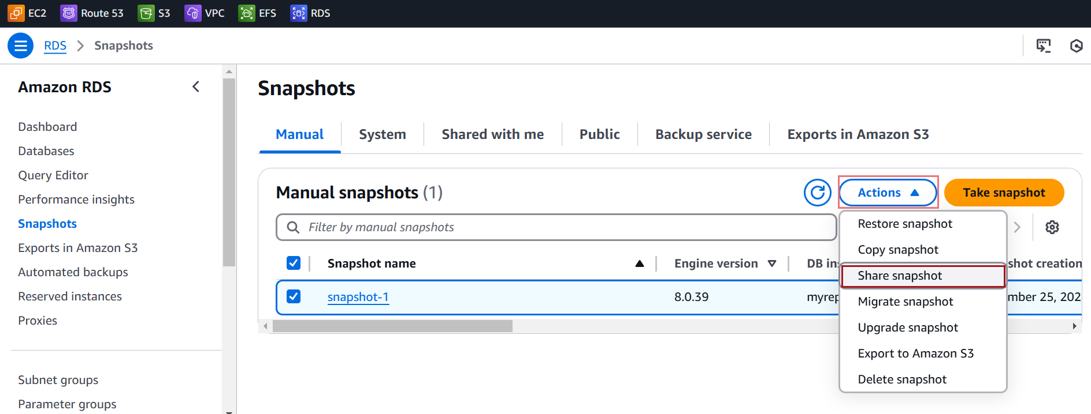

Enter AWS account ID with which you want to share the snapshot and Click on Add
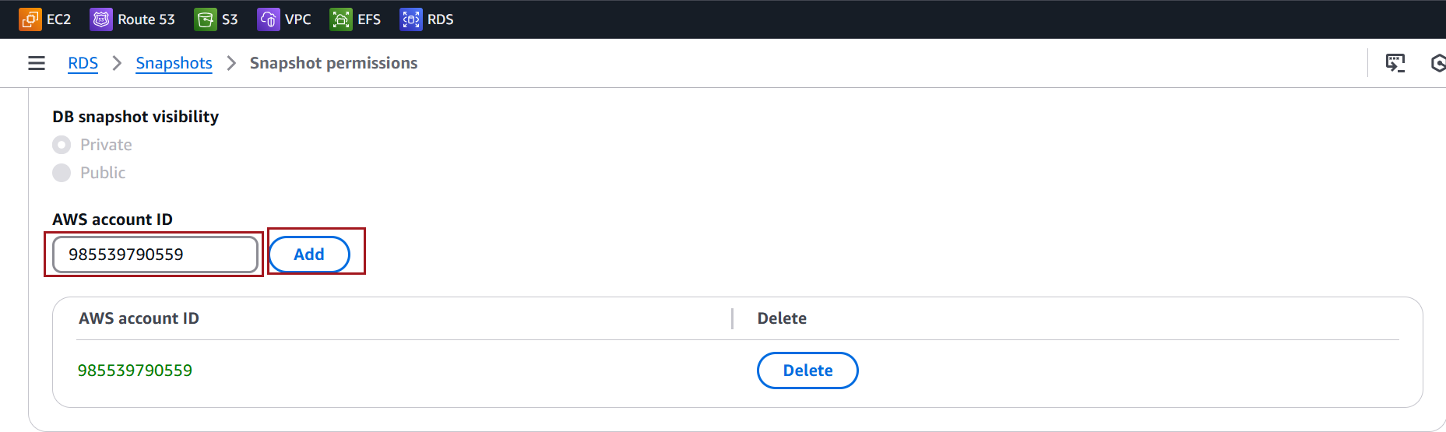

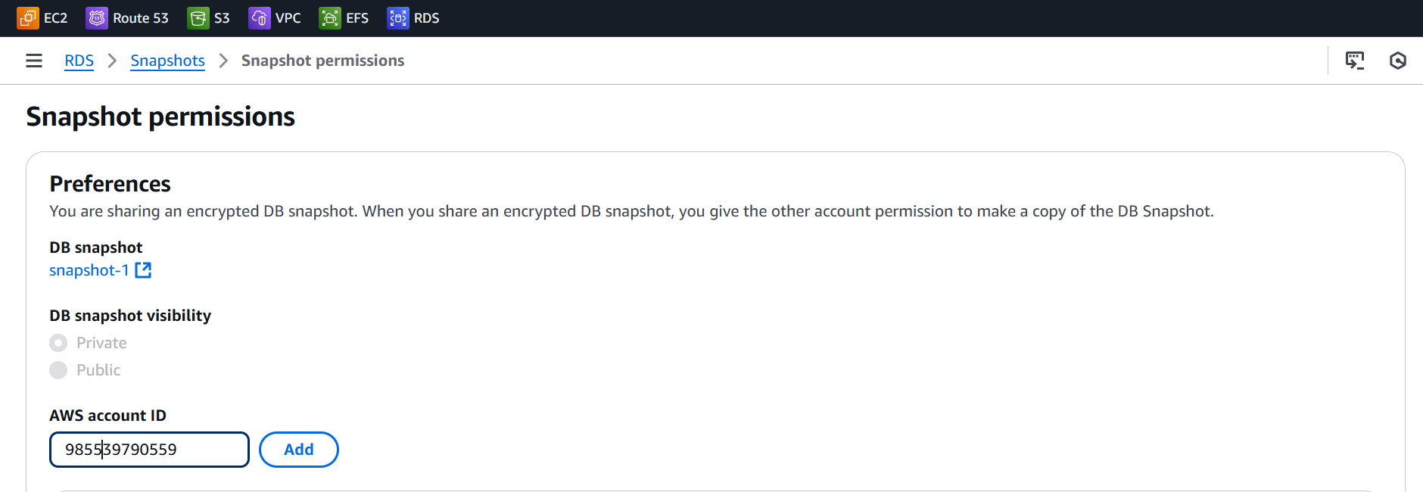

click Save to share the snapshot
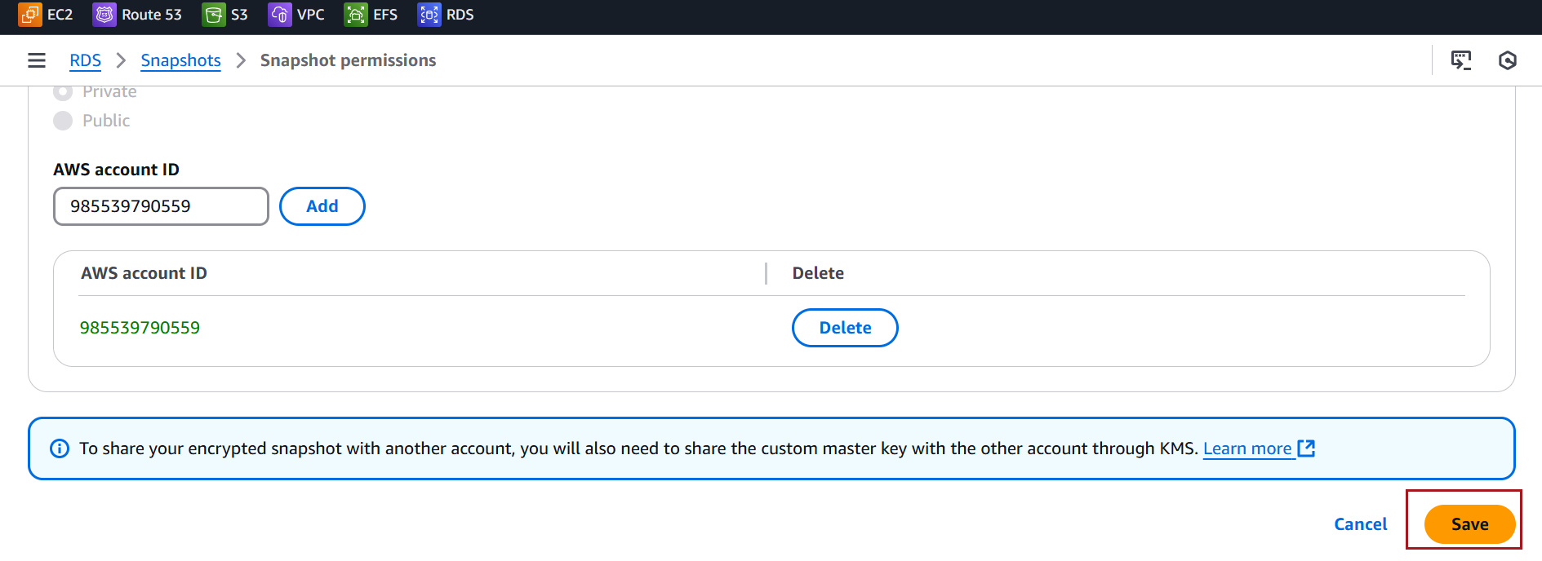
After saving, the snapshot will be shared with the specified account, and the status will be updated.

Screenshot for Migrating a DB snapshot
Choose Snapshots. On the Snapshots page, choose the Amazon RDS MySQL snapshot that you want to migrate into an Aurora DB cluster
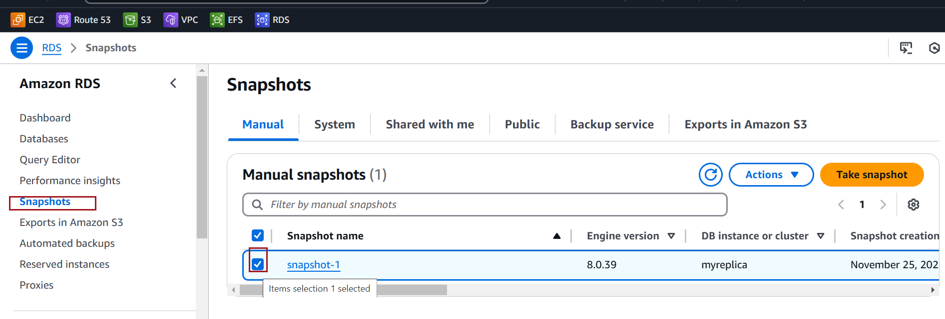

After selecting the snapshot, click on the Actions button (top-right) and choose Migrate snapshot
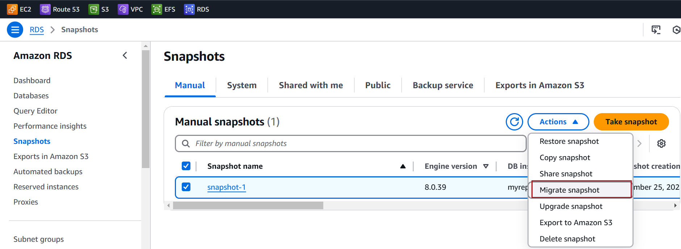

On the Migrate Database page, Select DB engine version
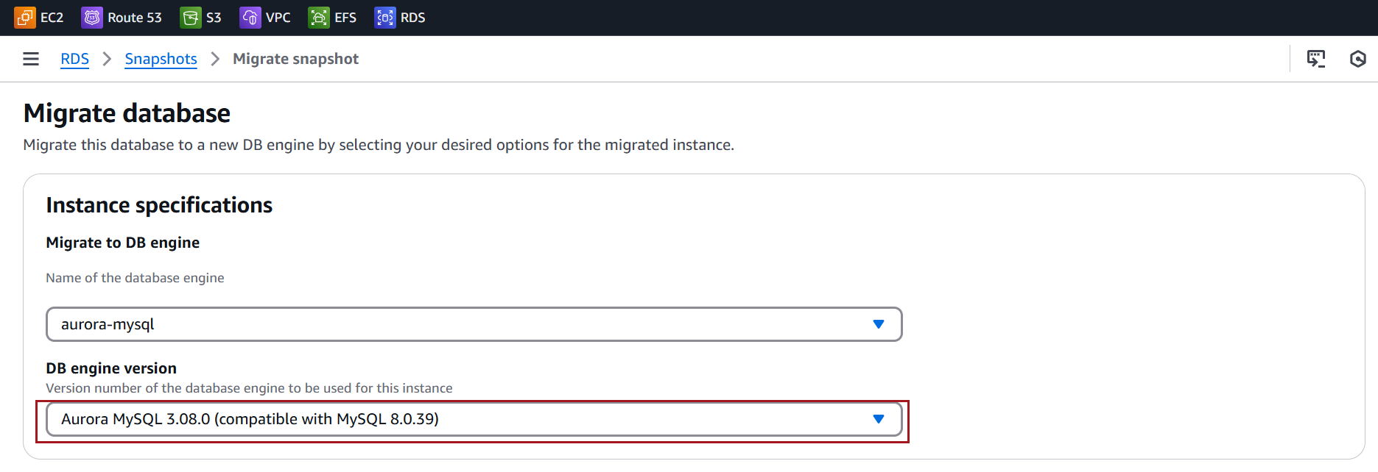

Enter DB instance Identifier
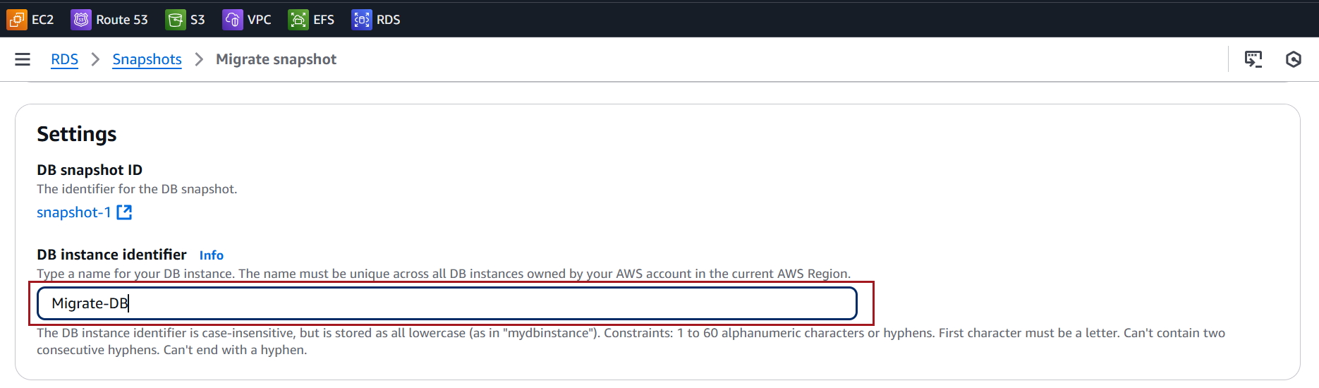

Ensure the VPC, subnet group, and security groups are correctly set so that the new Aurora cluster is accessible to your applications.
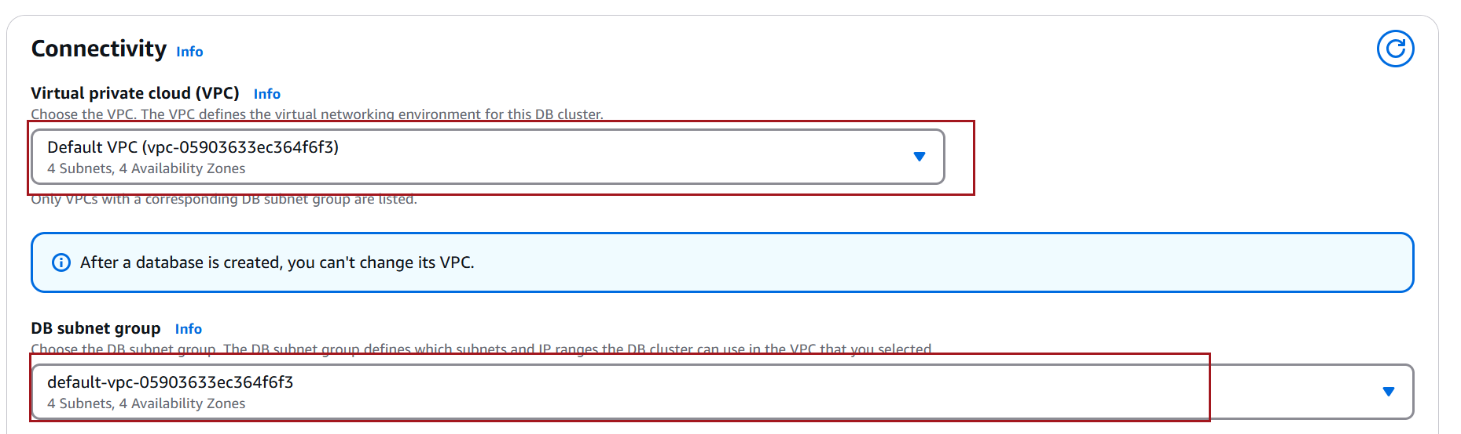

Set Public access to Yes if you want the RDS instance to be accessible over the internet.
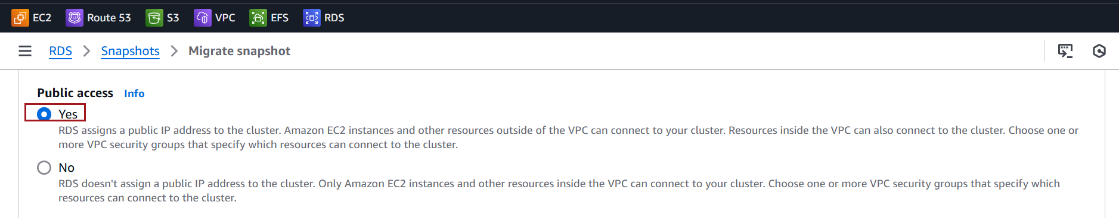

Click on Migrate
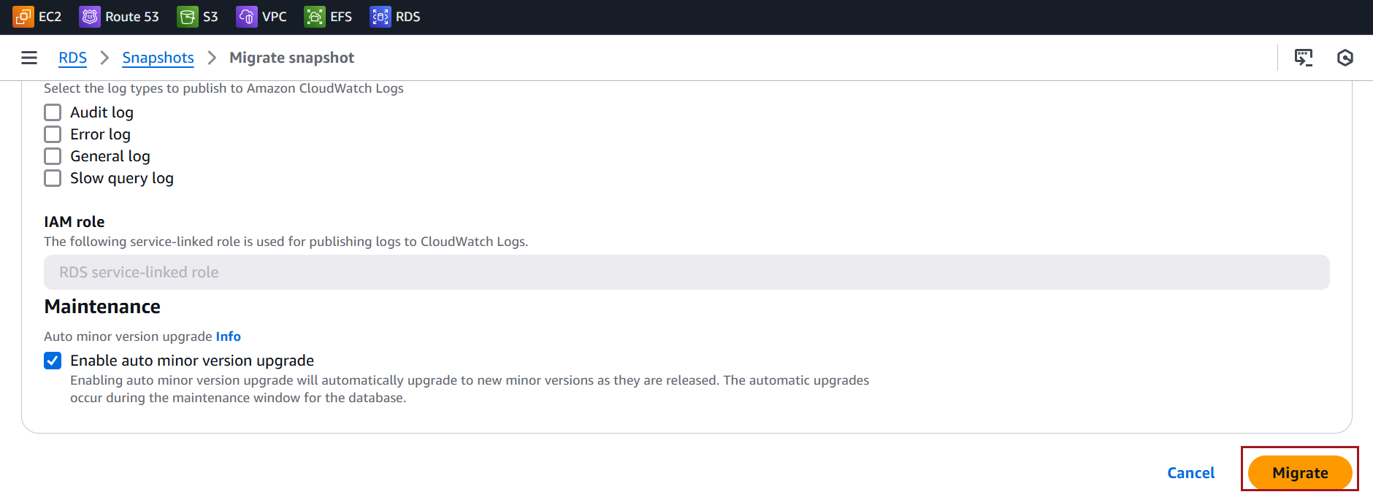

The migration process will take some time depending on the size of the snapshot and the database. You can monitor the progress of the migration in the RDS Console under Databases. Once the Aurora DB cluster is ready, the status will change to Available.
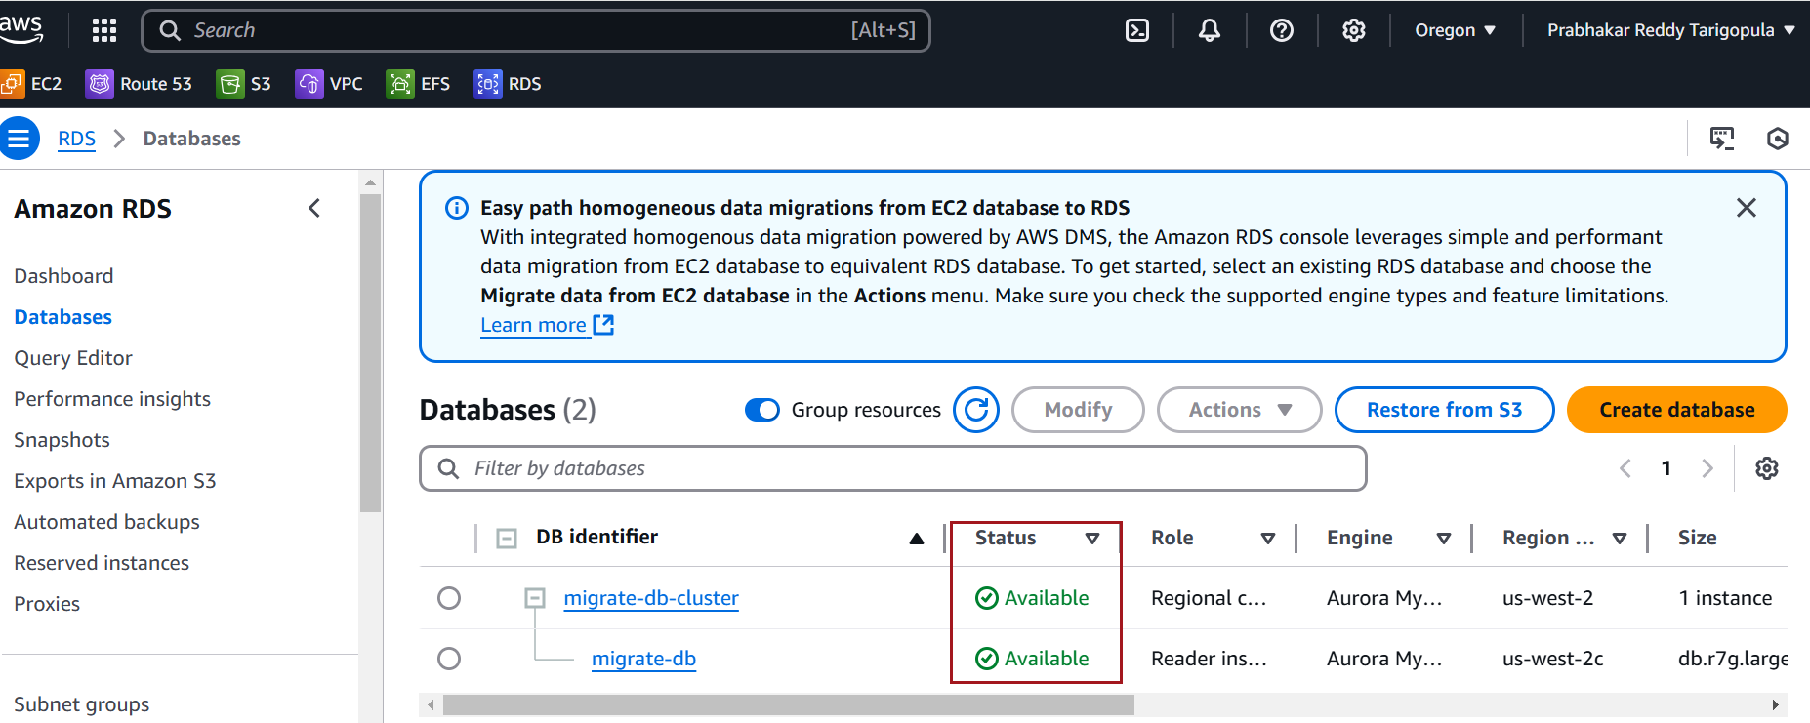

Screenshot for Upgrading a DB snapshot

In the navigation pane, choose Snapshots. Choose the snapshot that you want to upgrade


For Actions, choose Upgrade snapshot. The Upgrade snapshot page appears.
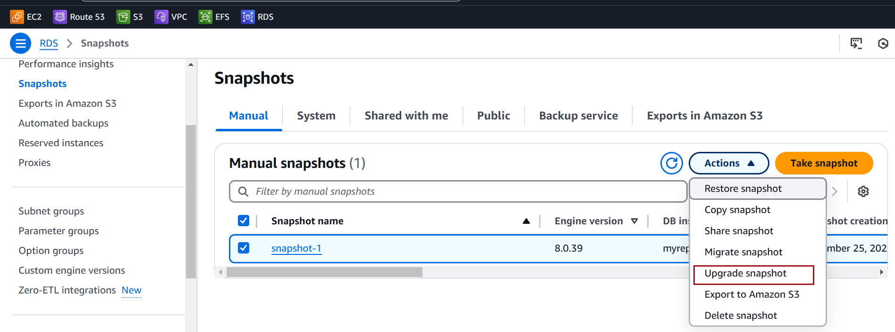

Choose the New engine version to upgrade to and Choose Save changes to upgrade the snapshot.
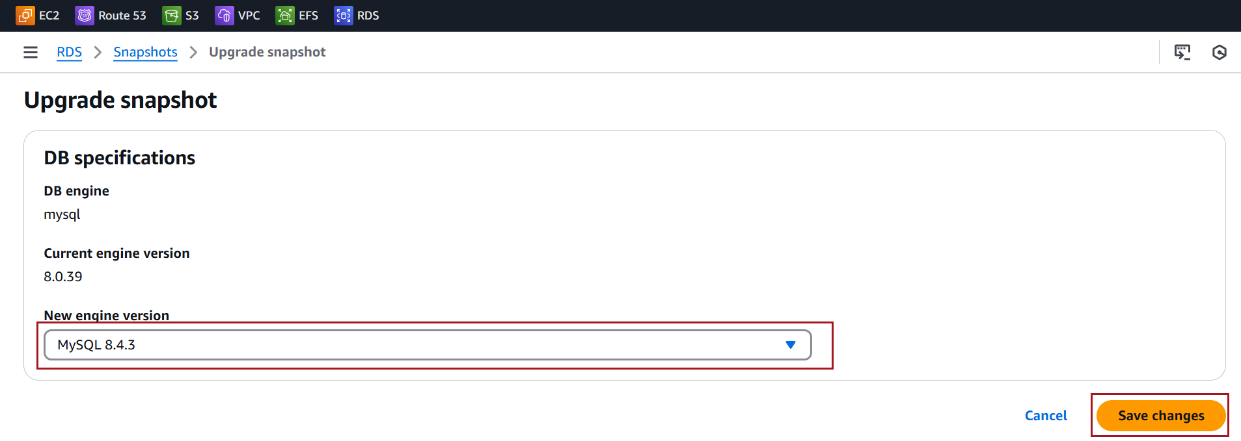
During the upgrade process, all snapshot actions are disabled for this DB snapshot. Also, the DB snapshot status changes from Available to Upgrading, and then changes to Active upon completion.
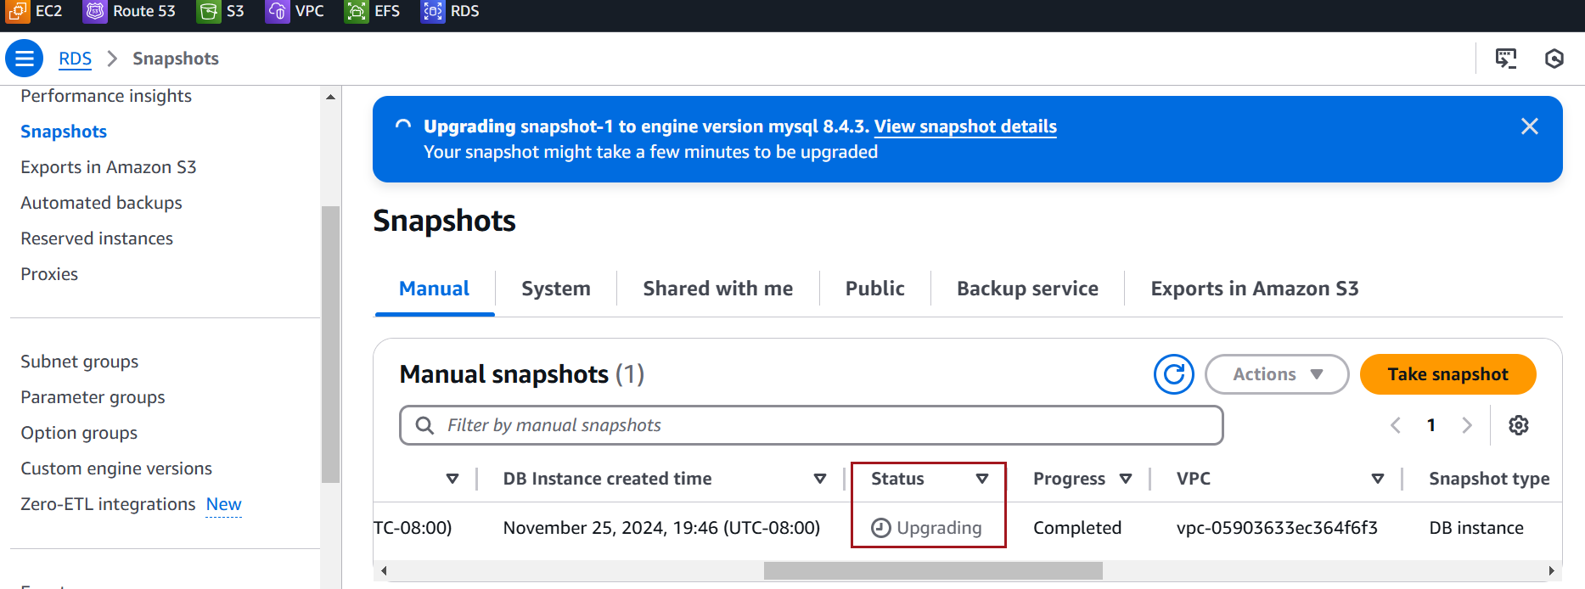

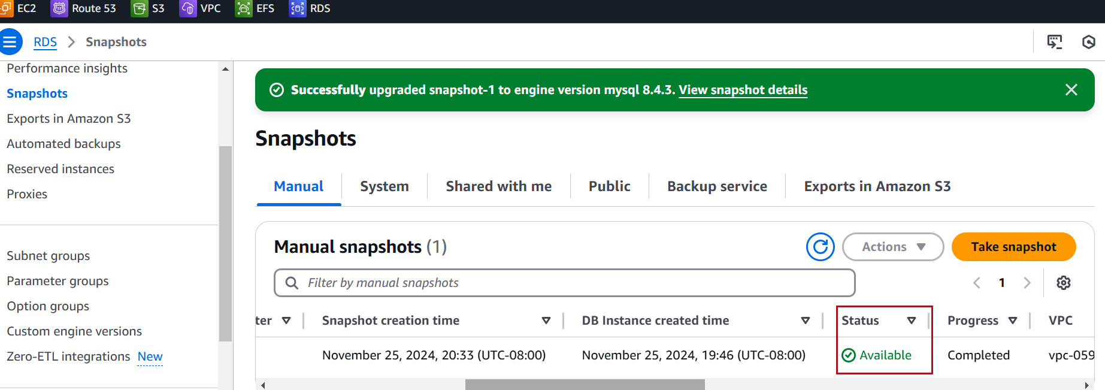

Screenshot for exporting Snapshot to Amazon S3

To export an Amazon RDS Snapshot to Amazon S3 securely using AWS Key Management Service (KMS), you need to create and use a KMS key for encryption during the export process

Steps for creating KEM Key
Search for KMS in the search bar and select Key Management Service from the list
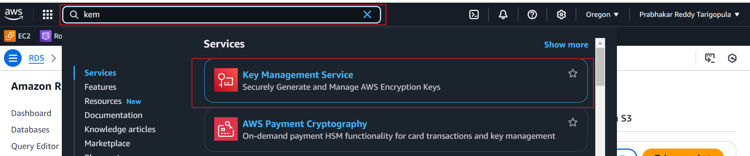

In the KMS Console, go to Customer managed keys. Click on Create key to create a new symmetric key .
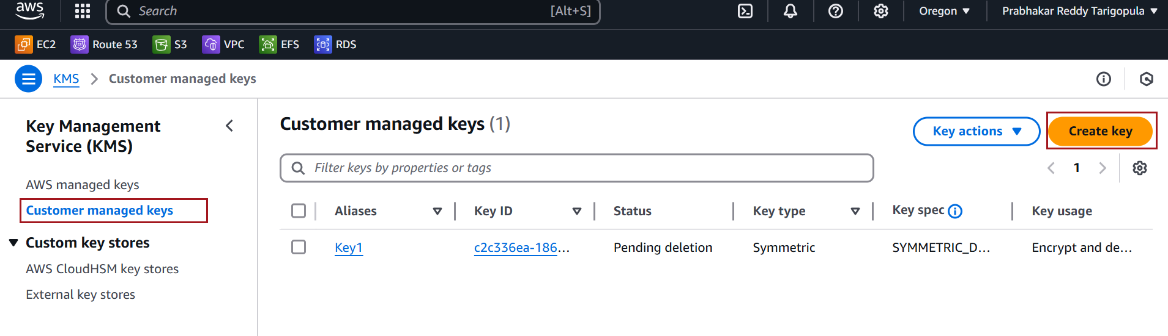

Select Key type , key Usage. Click on Next.
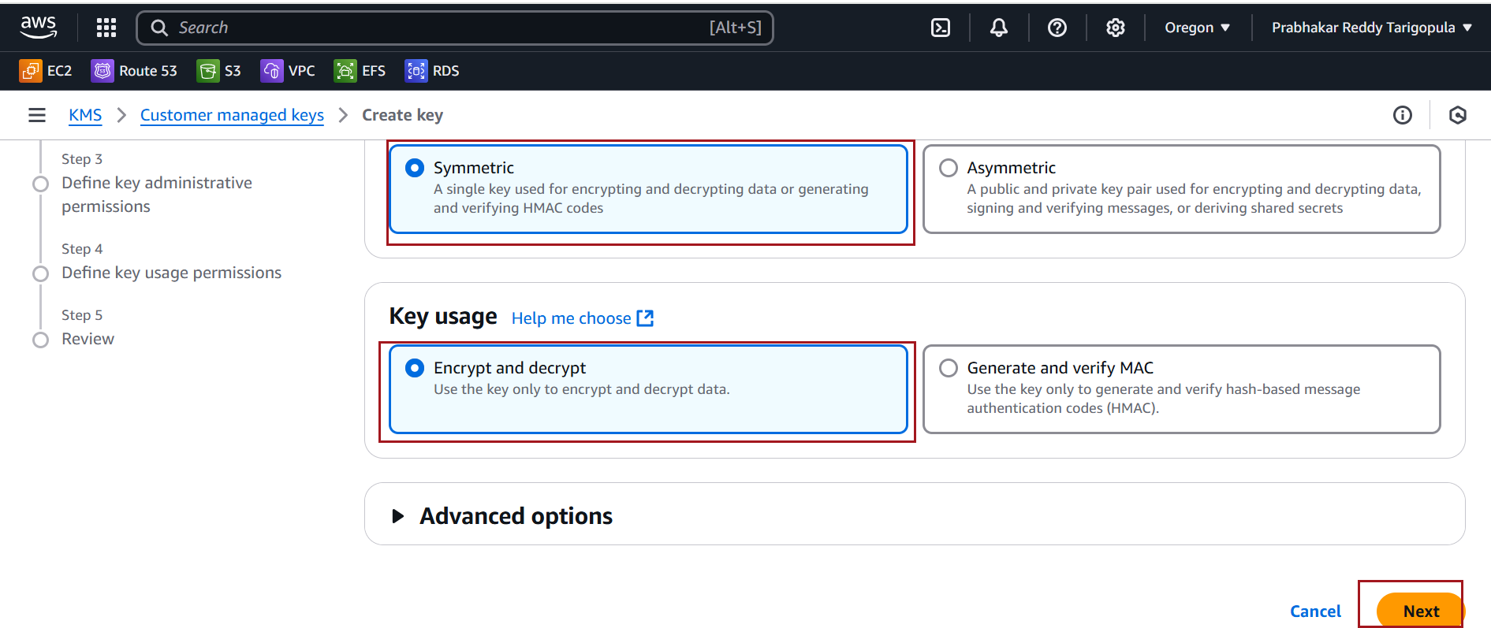

Provide Key Alias name (e.g., rds-export-key)
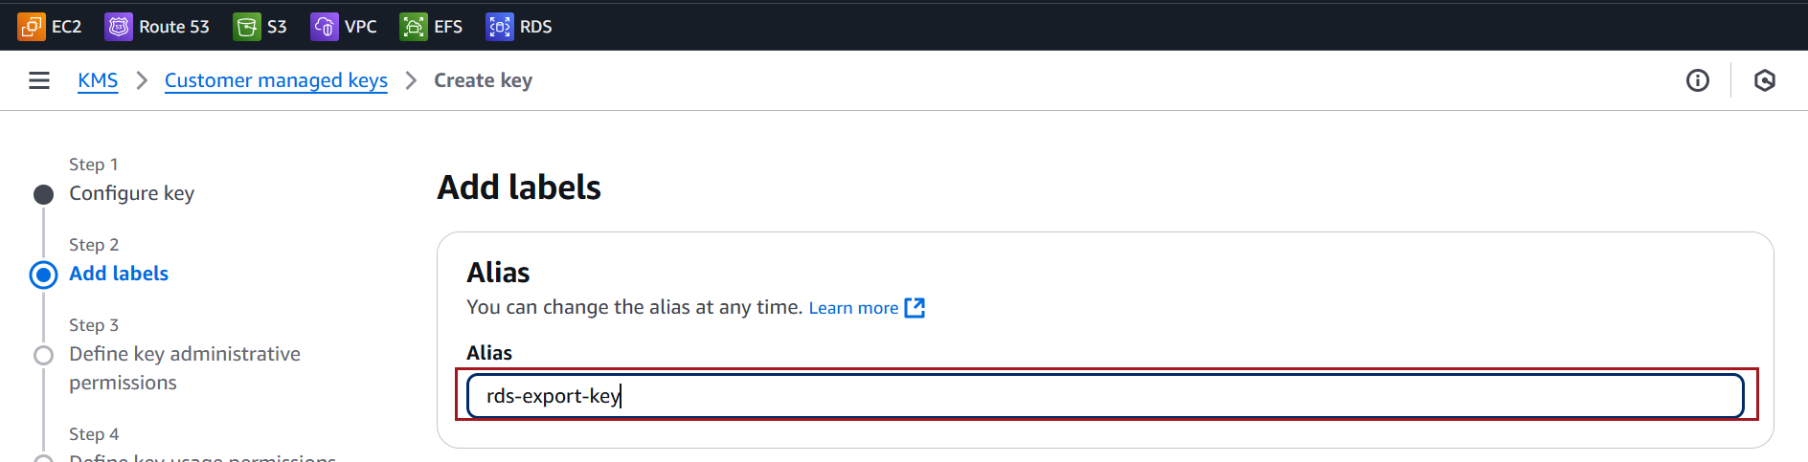

Click on Next
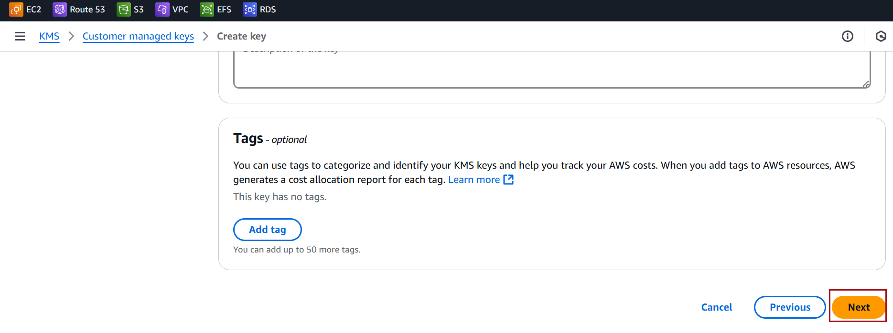

Assign AWSServiceRoleForRDS rols
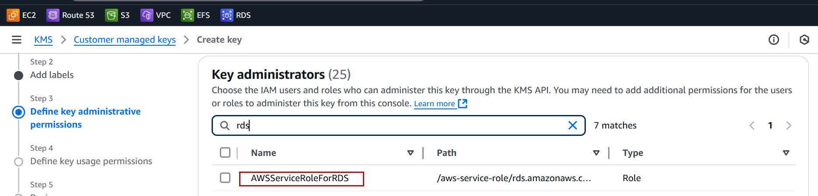

Leave default in the next screen and click on Next. click on finish
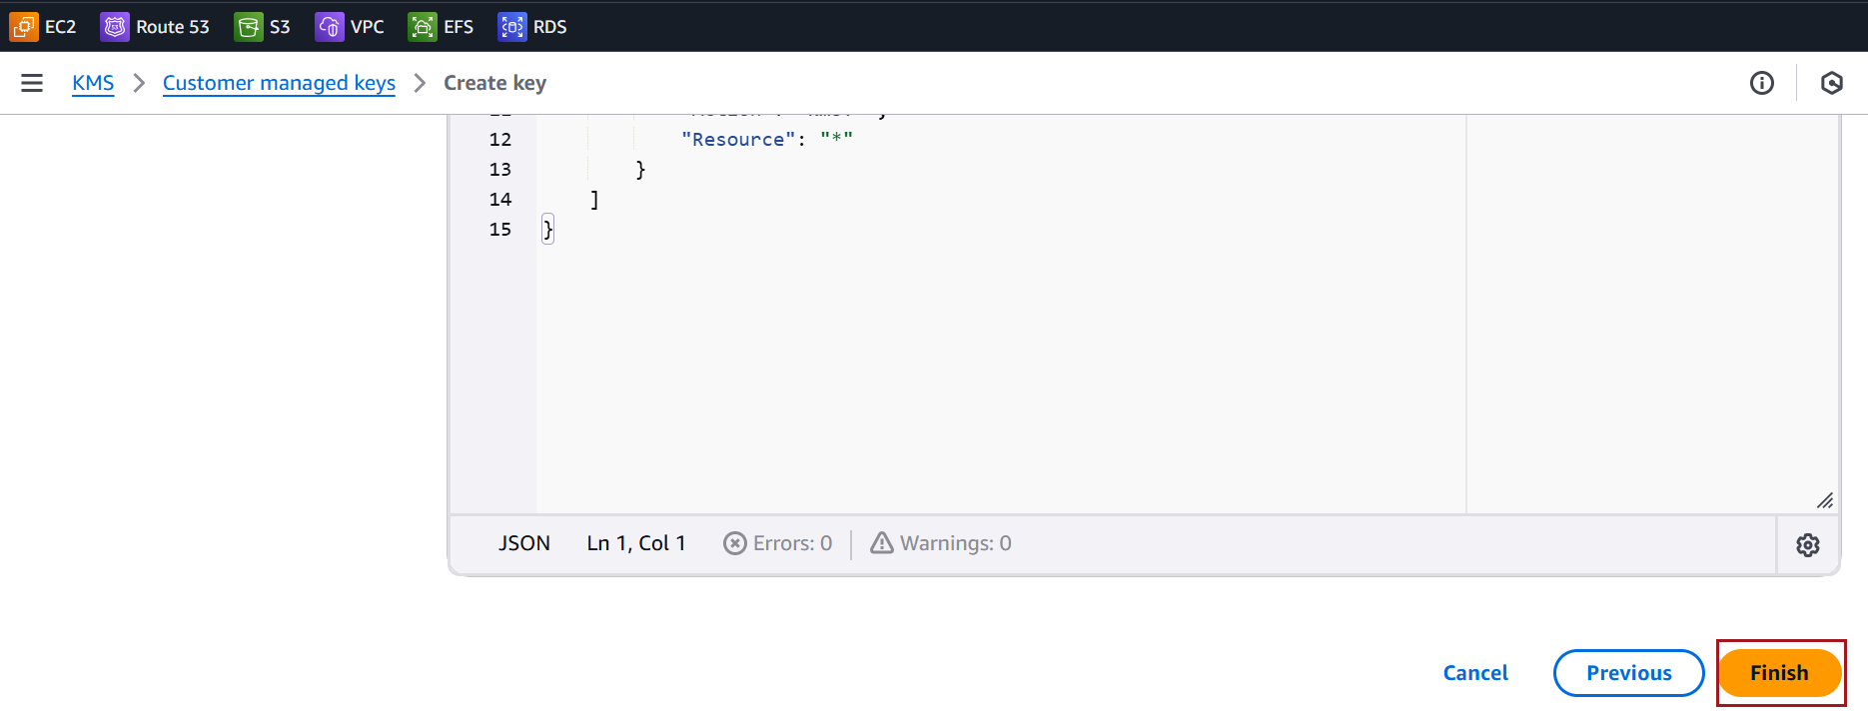

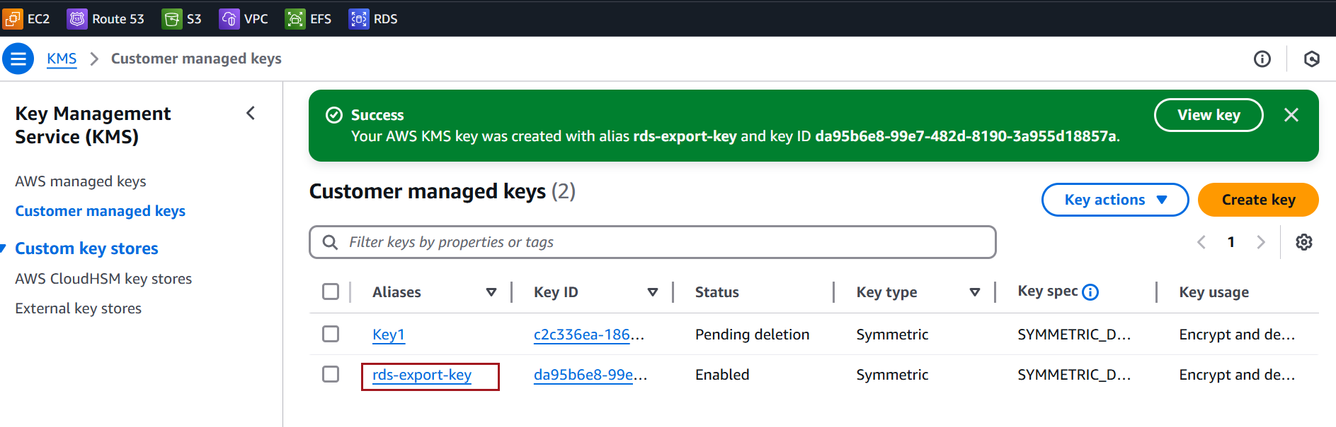

Verify S3 Bucket
Before exporting an Amazon RDS snapshot to an S3 bucket, you must ensure that the S3 bucket exists and is correctly configured
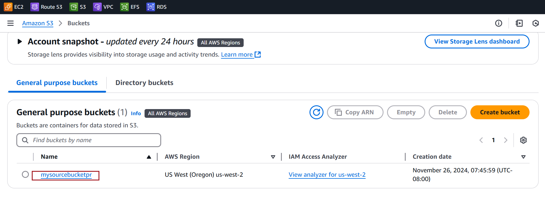

Export RDS Snapshot to S3
In the RDS Console, go to Snapshots and choose the snapshot you want to export to S3


With the snapshot selected, click Actions > Export to Amazon S3.
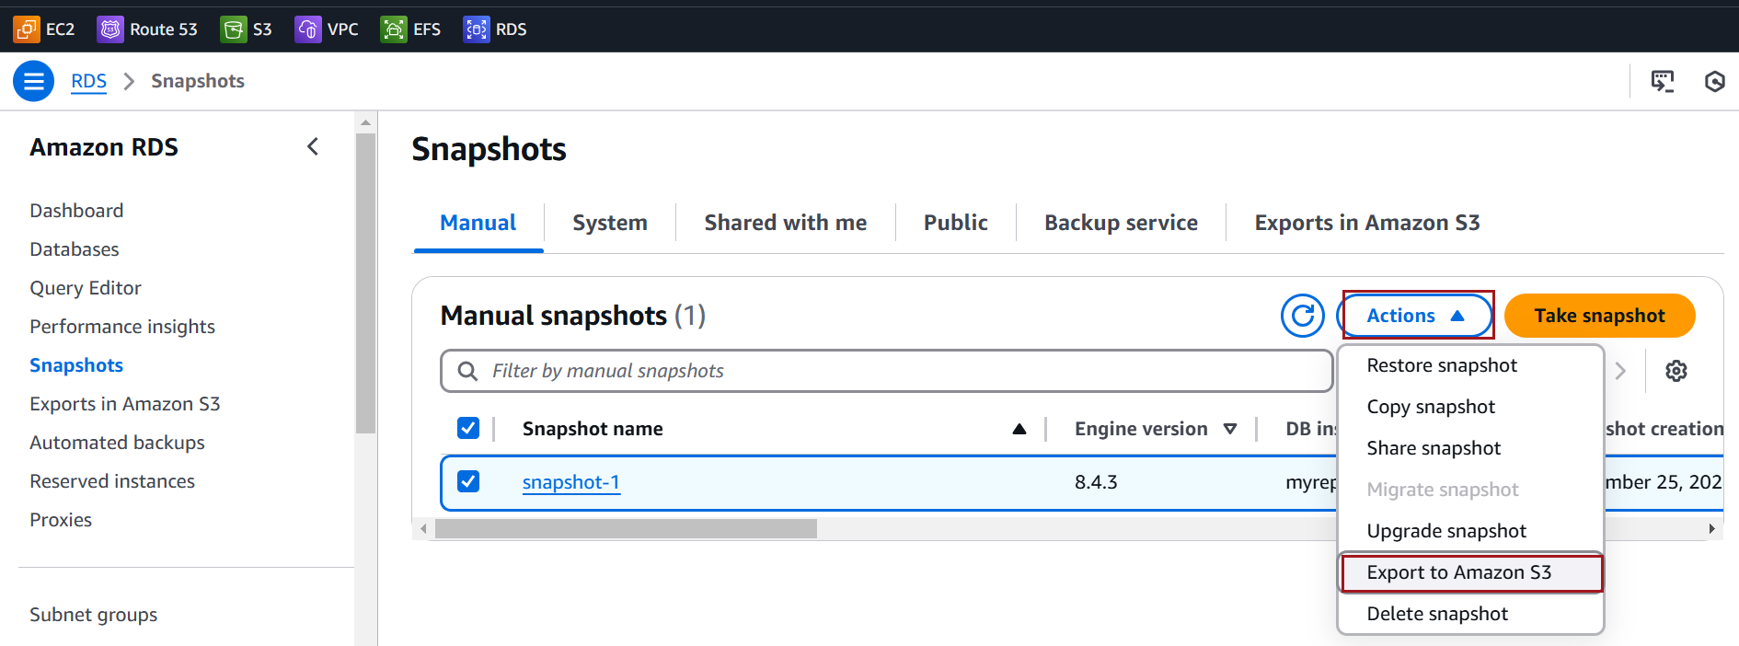

Enter the Export Identifier in the provided text field
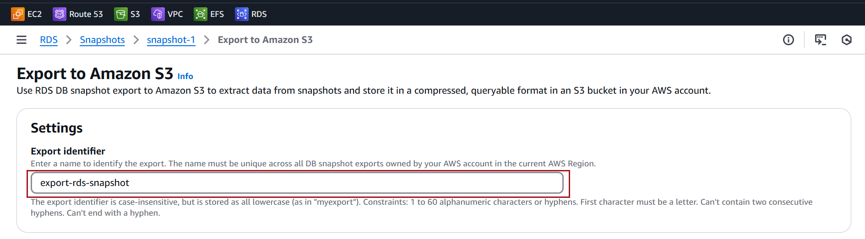

Choose the S3 bucket where you want to export the snapshot
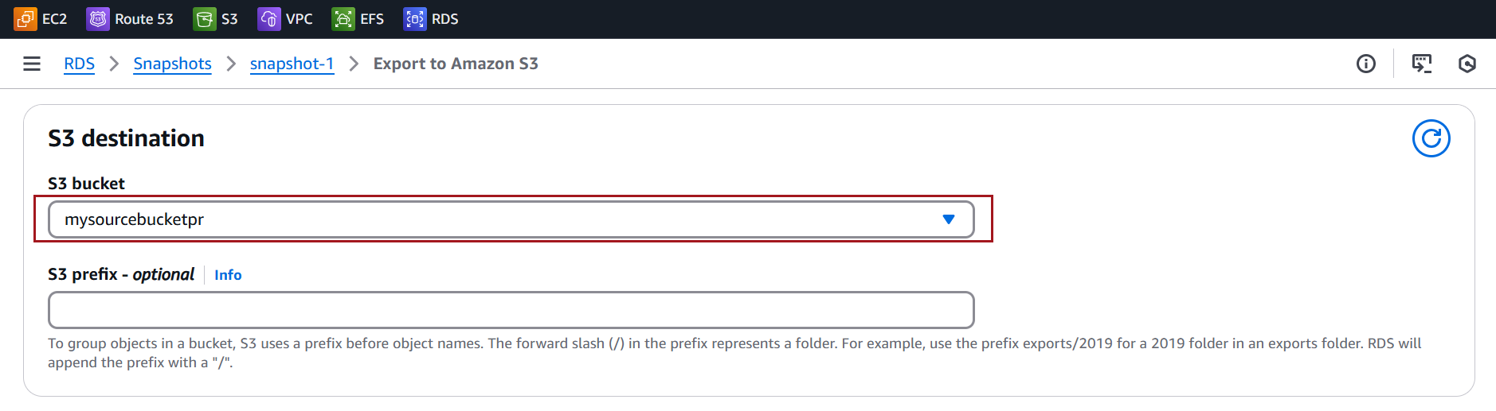

Choose the Create a new role option and specify the name of the IAM role
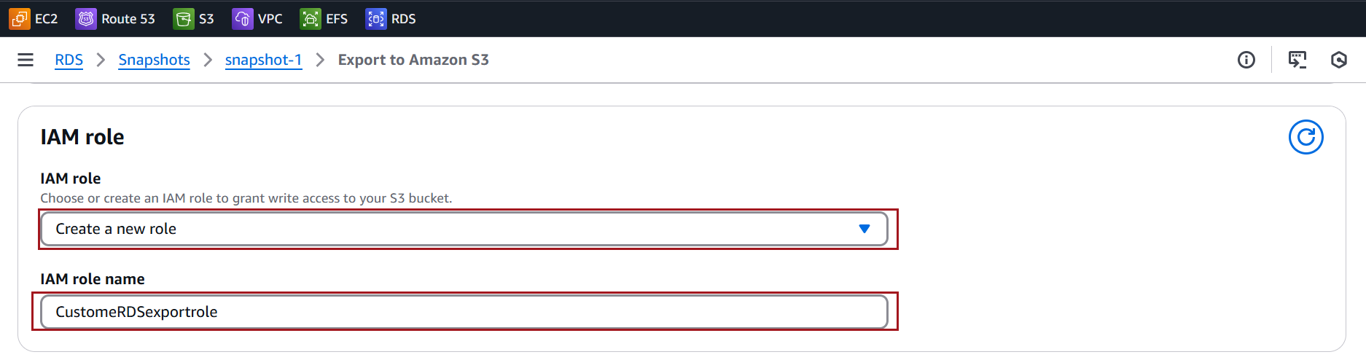

Choose the KMS key for encryption that you created. Click on export to Amazon S3
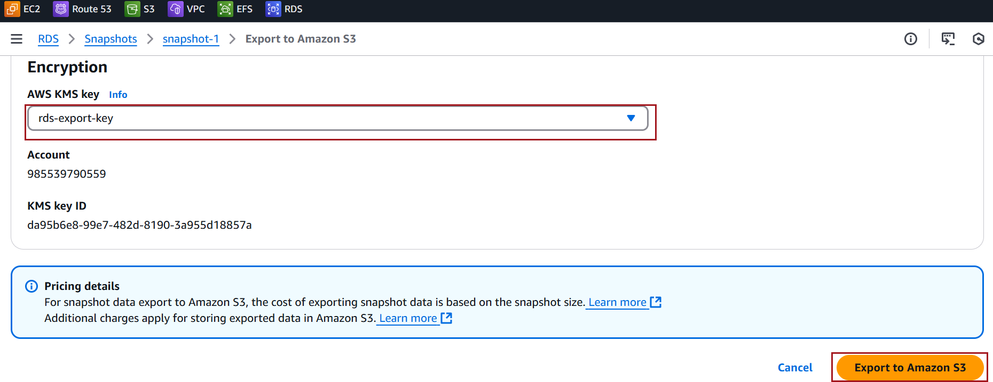
You can monitor the export status under Snapshots. The status will show as Starting while the process is in progress and will change to Available once the export is complete
